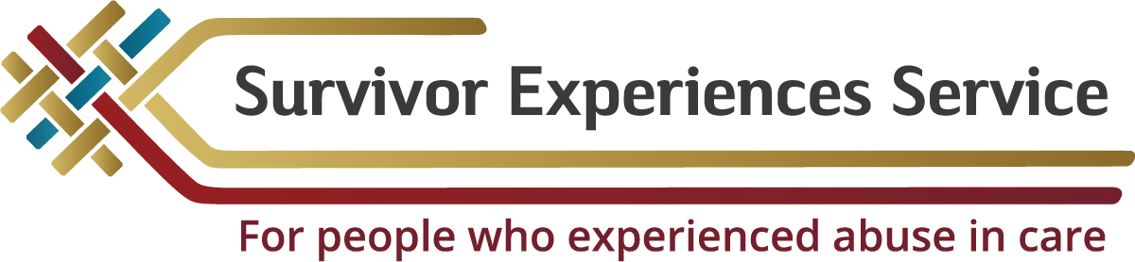

# Survivor Experiences Service Insights Report (July 2023 – 29 February 2024)

## Executive Summary

The Survivor Experiences Service was established in July 2023. Since then, it has gained useful insights that may help in the creation of the permanent redress system. While the Service took some time to set up, the insights show the importance of inclusivity, accessibility, and tailored support to help people who have been abused in care.

## Insights

A key insight is the need to expand the definition of 'Survivor'. It should include both direct victims and families, communities, and observers of abuse. This is needed for a redress system that addresses the full scope of harm caused.

Another insight was that the distrust of government agencies and accessibility issues creates barriers for both survivors and the Service. Humanizing meetings, providing accessible information, and creating easy processes are crucial steps to build trust and confidence.

Redress should be more than just financial compensation. It should include various aspects based on survivor feedback. Reducing turnaround times for claims processes and minimizing re-traumatization are important in the redress system to meet the diverse needs of survivors.

Processes for survivors with disabilities and impairments need careful attention to ensure inclusivity and accessibility. Tailored approaches are necessary to meet the diverse communication and accessibility needs for survivors.

## Insights for priority groups

The Service has an emphasis on four priority groups – Māori, Pacific, Deaf and Disabled, and LGBTQIA+ (Lesbian, gay, bisexual, transgender, queer or questioning, intersex and asexual), MVPFAFF+ (Mahu, Vakasalewa, Palopa, Fa'afafine, Akavai'ne, Fakaleiti (leiti), Fakafifine) and Takatāpui. This is because these groups are often underrepresented in services like this. Meeting with these groups can present challenges that need specific approaches. The Service aims to build trust through cultural understanding, addressing diverse communication needs, and understanding historical discrimination.

For the Pacific community, there has been noticeable hesitation and reluctance to meet with the Service due to past experiences with government institutions. To address this resistance, the Service will focus on building relationships from a place of trust and work towards establishing a safe and supportive environment.

For the Deaf and disabled/impaired communities, each community has specific needs and communication preferences that cannot be generalized. A tailored approach is needed that acknowledges and addresses individual concerns and barriers. The Service is working on developing different communication methods, incorporating Deaf kaitakawaenga to support Private Sessions, and adapting our messaging to better resonate with Deaf communities and those that have disabilities or impairments.

For the LGBTQIA+, MVPFAFF+ and Takatāpui communities, meetings with the Service have been positive. However, turning these into registrations and private sessions has been difficult due to these communities often not being believed. In combination with discrimination, stigma, and marginalization, this has led to deep-seated mistrust of institutions and services. The Service understands the need for targeted and tailored approaches to build trust and meaningful participation with these communities.

For Māori communities, it is important that Māori are kept involved in the decision-making of processes for Māori survivors. Based on feedback received from iwi and hāpu, the Service will look to set up wānanga on how best to start addressing these concerns and involving communities in meaningful ways. The Service has been using a grass-roots approach for this community, utilizing community-led events, maintaining ongoing relationships, and ensuring authentic and culturally sensitive engagement practices.

## Conclusion

In conclusion, these insights show the importance of a Survivor-centered approach when designing the permanent redress system. By addressing key themes, challenges, and effectively engaging with priority groups, the new redress system can provide meaningful support to survivors and their communities. Building cultural competency, consulting with communities, and proactive engagement are vital to meet the diverse needs of survivors.

To contact the Survivor Experiences Service, people can:

* Phone 0800 456 090 (NZ) or 1-800 456 032 (AUS). Our phone lines are open 8:30am – 4:30pm Monday – Friday.
* Email contact@survivorexperiences.govt.nz
* Text 8328
* If people are Deaf, hard of hearing, deafblind, speech impaired or find it hard to talk, they can use the New Zealand Relay Service - [www.nzrelay.co.nz](http://www.nzrelay.co.nz)

To view the full report visit [www.survivorexperiences.govt.nz](http://www.survivorexperiences.govt.nz)

End of information | **Survivor Experiences Service Insights Report (July 2023 – 29 February 2024)**

This Large Print document is adapted by Blind Citizens NZ from the standard document provided by the Survivor Experiences Service (Department of Internal Affairs)