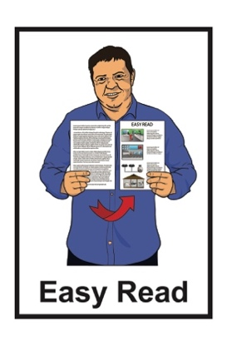
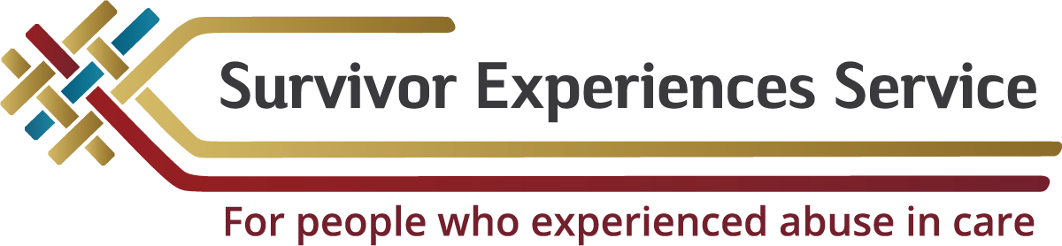

Information about meeting with the Survivor Experiences Service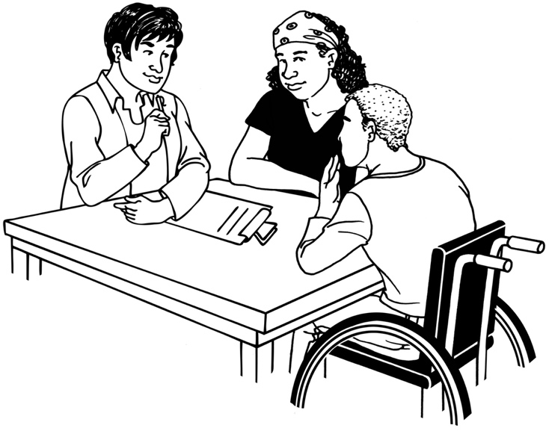

Published: February 2024

Before you start


This document talks about abuse.

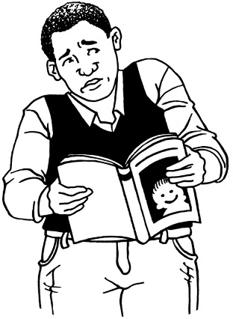

This information may upset some people when they are reading it.

This information is not meant to scare anyone.

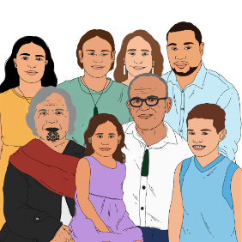
If you are upset after reading this document you can talk to your:
- whānau / family
- friends.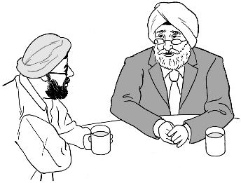


This is a long document.

It can be hard for some people to read a document this long.

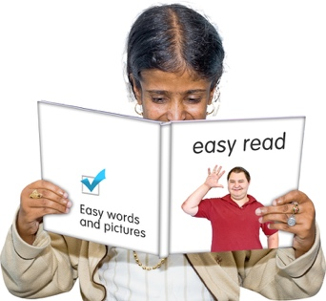
Some things you can do to make it easier are:
- read it a few pages at a time
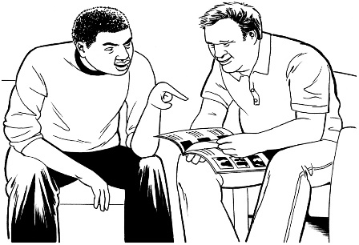
- set aside some quiet time to look at it
- have someone read it with you to support you to understand it.

What you will find in here

Page number:
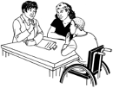

What this document is about 4

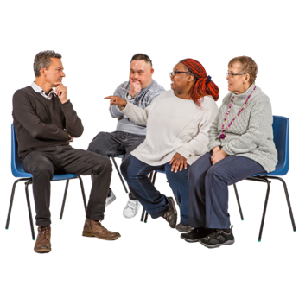
Getting ready for your meeting 11

Who will be at the meeting 16
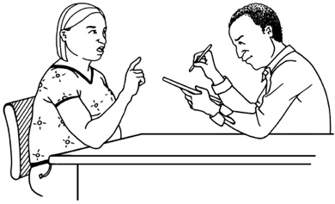

What will happen in your meeting 27

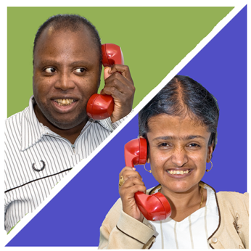
After the meeting 29

How to contact us 36

What this document is about


This document is from the Survivor Experiences Service.
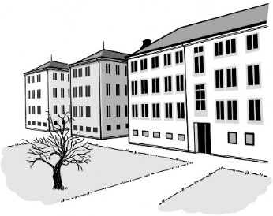

The Survivor Experiences Service is for:
- people who have experienced abuse while in care
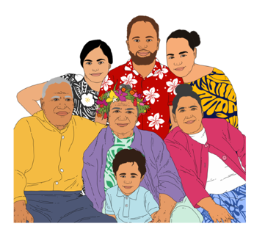
- people to talk about what happened to them
- people and their whānau / families to get the support they need.

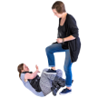
Abuse can be:
- physical – kicking or hitting you
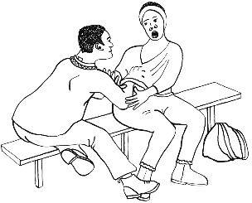
- sexual – doing sexual things to you that you do not want like:
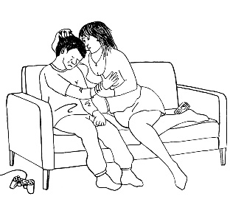
- touching your body or private parts
- kissing you
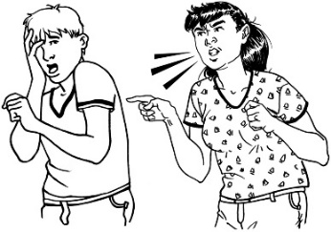
- making you have sex – this is called rape
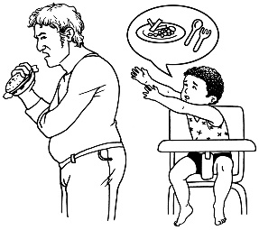
- emotional – yelling or saying things to you that are not nice
- neglect – not giving you the things or care you need.

In this document being in care means that the Government or a faith-based institution was in charge of your care.


Faith-based institutions are run by religious groups like churches.
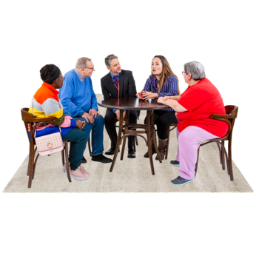

People who have been through abuse in care are sometimes called survivors.


In this Easy Read document when we say the service we mean the Survivor Experiences Service.

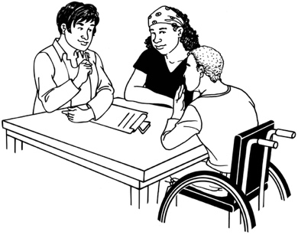
This document is about what will happen if you choose to have a private session with the Survivor Experiences Service.

Private session means a meeting. that is just for:
- you
- a few people from the service
- a support person if you want them.
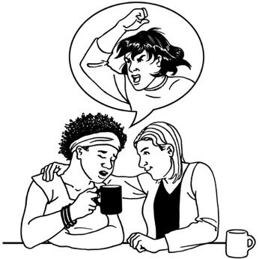

In your private session you can talk about the things that happened when you were in care.


Talking about what happened can make you feel better.

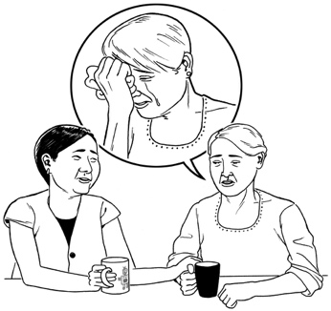
We know that it can be really hard to talk about bad things that have happened to you.


You might have a lot of feelings about the things that have happened to you.
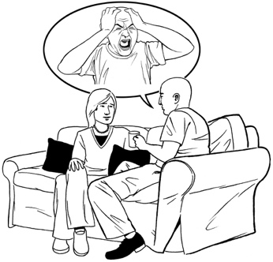

We will support you with any feelings you have.


We will treat you with respect.

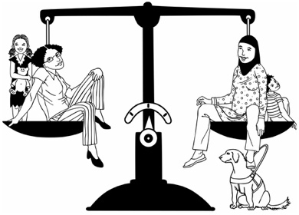
Respect means treating people:
- fairly
- like they are important.

We will take care of your wellbeing.

Wellbeing means things like:
- feeling okay about ourselves
- taking care of ourselves
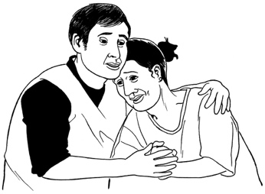
- getting support when we have feelings like being:
- sad
- worried
- angry.

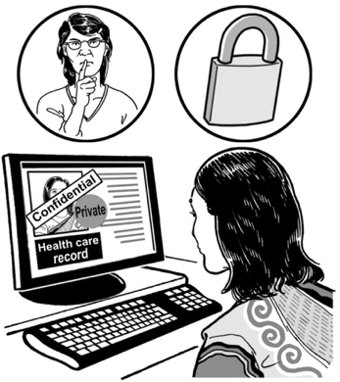
We will keep your information private.

Private means that you are in charge of information about yourself.
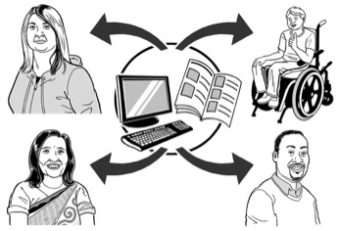

It means that you know:
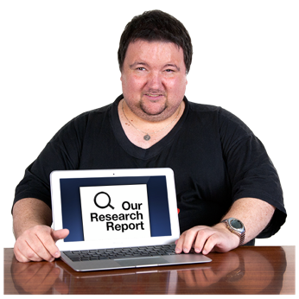
- who can see information about you
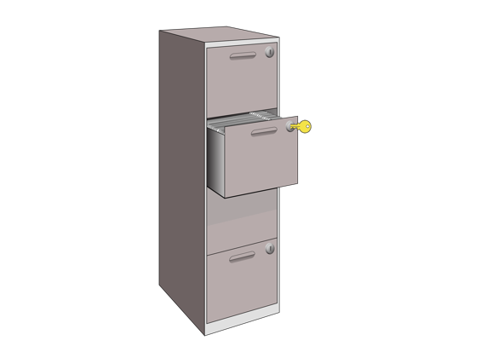
- how information about you will be used
- how information about you will be kept safe.

Getting ready for your meeting

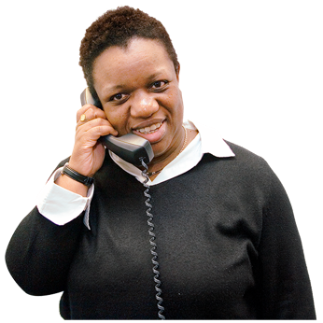
1 of our facilitators will get in touch with you.

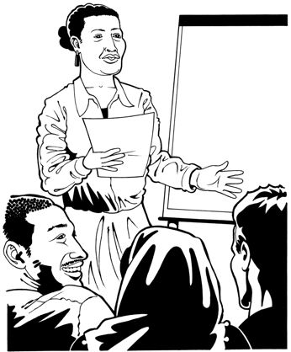
Facilitator means someone whose job is to make sure:
- everything runs smoothly
- everyone knows what they need to do.


The facilitator will tell you:
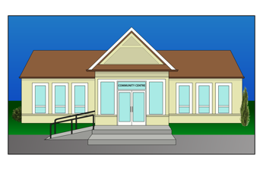
- when your meeting is
- where your meeting is.


You can bring something with you to support you to feel:
- calm
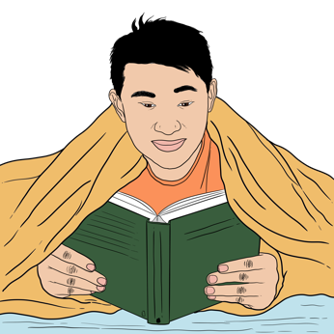
- safe
- comfortable.


You might want to bring:
- a blanket
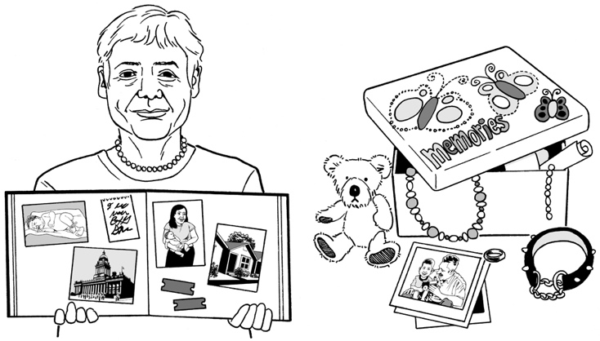
- a candle
- a special photo
- something that is important to you.

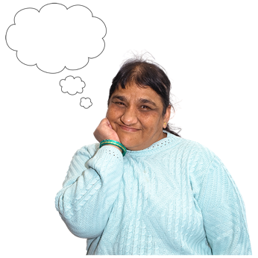
You might want to plan the things you want to say at your meeting.


You can write down what you want to say.

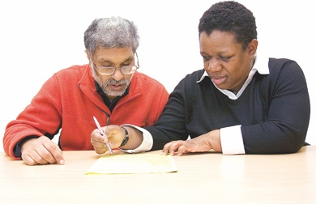
We can give you support to write down the things you want to say.

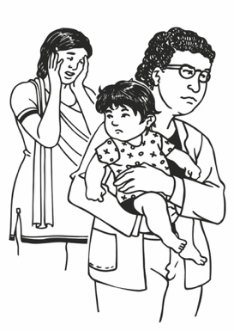
Some things you might want to talk about are:
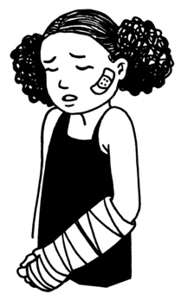
- what your childhood was like
- why you were put in care
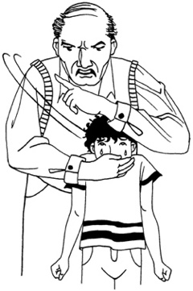
- what happened to you when you were in care
- who abused you
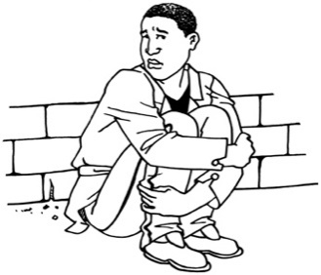
- if anyone knew you were being abused
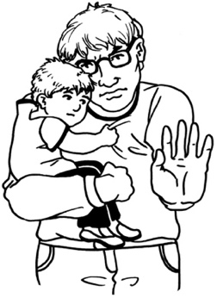
- the ways that being abused has affected your life
- what could have been done to keep you safe.


Abuse happened in care run by:
- churches

- the Government.


We want to know what you think those organisations should do for people who were abused in their care.

Who will be at the meeting

At your meeting there will be a:
- facilitator
- kaitakawaenga.

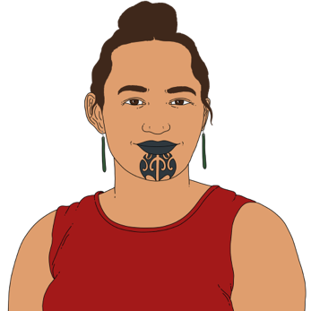
A kaitakawaenga is someone who:
- can be trusted
- has a lot of mana.

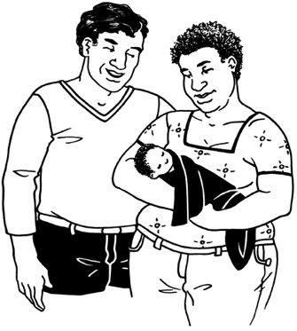
Māori believe that everyone has mana from the time they are born.



Mana is the spiritual life force / power that is found in all of the universe.

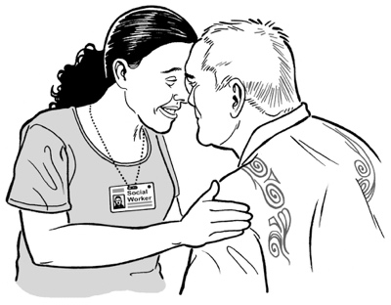
Having mana:

- means someone has a strong sense of confidence / knowledge about them
- might affect how other people see / think about them.

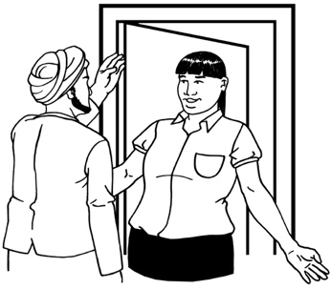
The facilitator will welcome you to the meeting.

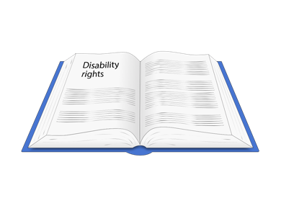
They will tell you about your rights.

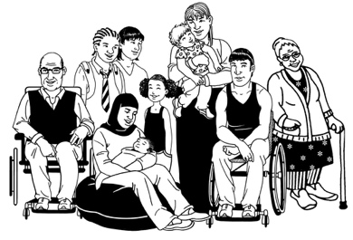
Rights means the things everyone should:
- have
- be able to do.

For your private session rights are things like:

- choosing who can see information about you
- being able to change your mind about taking part.

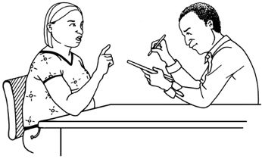
If you say it is okay the facilitator will:
- write down the things you say
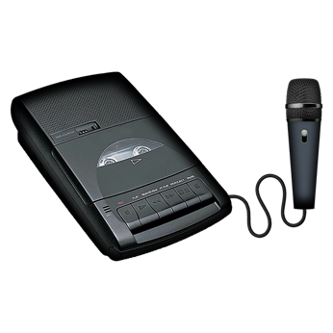
- make an audio recording.

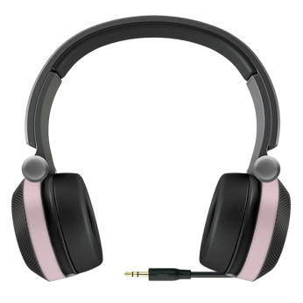
Audio recording means making a recording of the meeting that you can listen to later.

We will only record sound.
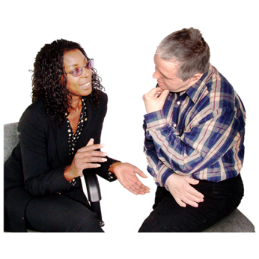

The kaitakawaenga is there to listen to you.

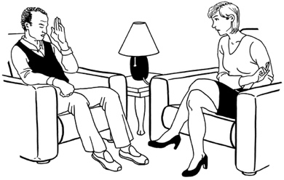
A wellbeing advisor will be there before / after your meeting.

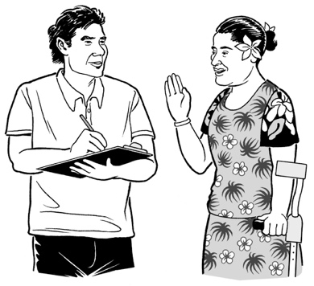
Wellbeing advisor means someone whose job is to:
- make sure you are okay
- sort out any support you need / want.

The wellbeing advisor can be in your meeting if you want.

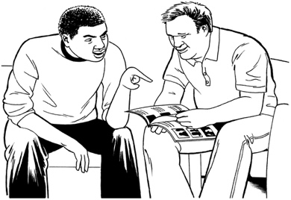
If you need support after your meeting the wellbeing advisor can get you:
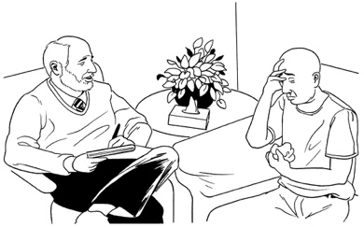
- counselling
- mirimiri
- something else that you need.

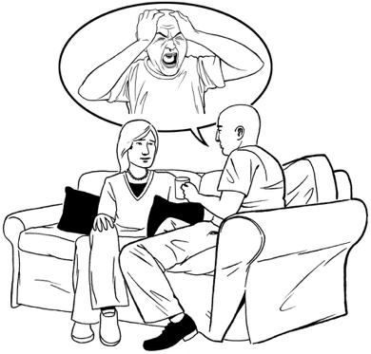
Counselling means talking to a trained person called a counsellor about things that affect you.

A counsellor can support you to deal with your:
- feelings
- worries.

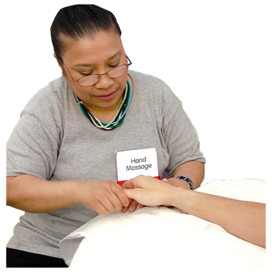
Mirimiri is a kind of massage.

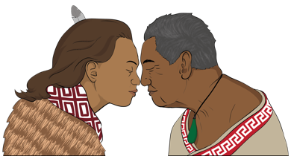
It is something Māori use for healing.

Mirimiri works with your wairua.

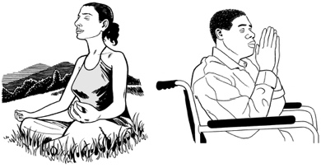
Wairua means your:
- spirit

- emotions / feelings
- mauri / lifeforce.

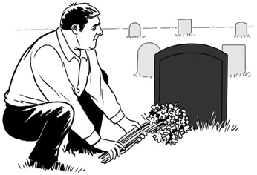
Some people believe it is the part of you that lives on after your body has died.


You can bring a support person to your meeting.

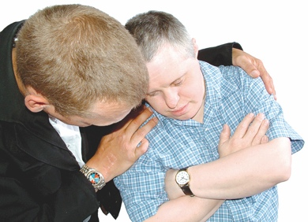
Support person means someone who:
- assists you to do things
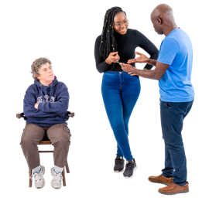
- gives you support with your feelings.

A support person cannot talk for you.

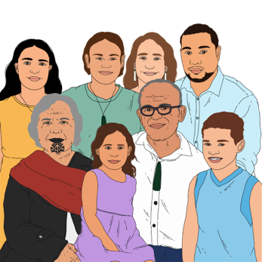
Your support person could be:
- someone from your whānau / family
- a friend
- someone you feel close to.

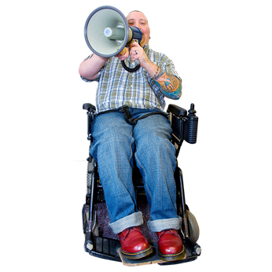
You can also bring an advocate with you.

Advocate means someone who can:
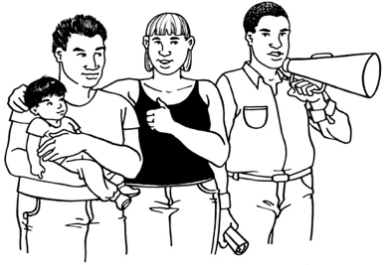
- support you to speak up for yourself
- speak up for you.

Please tell us about anyone you are bringing before your meeting.

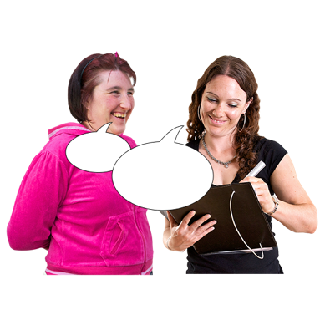
Please tell us if you need support with:
- talking

- hearing
- understanding things people say.

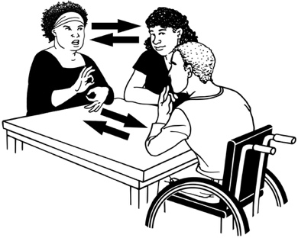
We can get you a:
- communication assistant
- interpreter.

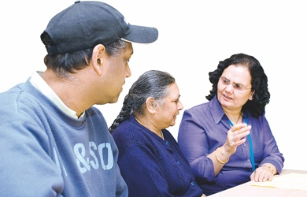
Communication assistant means someone who is trained to support you to:
- understand things
- share your thoughts.

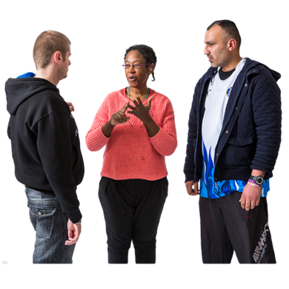
Interpreter means someone who supports people who do not use the same language to understand each other.
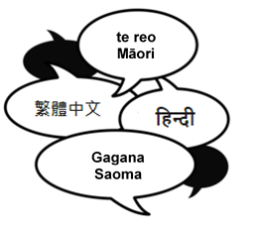

You can use an interpreter if you:

- speak a language other than English
- use New Zealand Sign Language.

Please tell us as soon as you can if you need a:
- communication assistant
- interpreter.

What will happen in your meeting

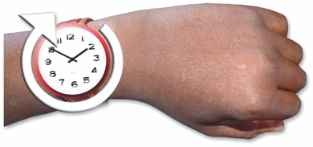
The meeting will take about 1 hour and 30 minutes.

You can tell the story of your abuse in care.

The kaitakawaenga will listen to what you say.


The kaitakawaenga will make sure they understand about what has happened to you.

They might ask you some pātai / questions.

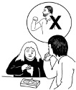
You do not have to talk about anything you do not want to.


You can stop the meeting any time you want to.

The facilitator will:
- write down what you say
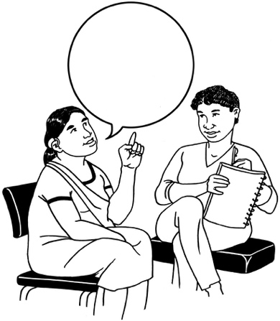

- make an audio recording.

You can tell the facilitator not to write / record what you say.

After the meeting


You might have some very strong feelings after the meeting.

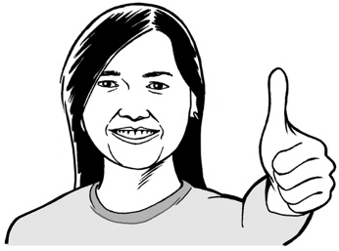
You might feel:

- good that someone has listened to you
- proud about speaking up about what has happened

- glad that it is over
- angry about your abuse
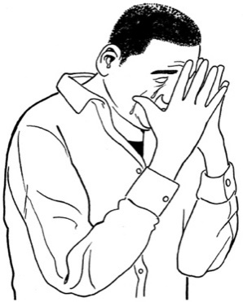
- sad about the things that have happened to you
- a mix of things.

Any way you feel is okay.

The wellbeing advisor will ask you how you are feeling.

They can get you support if you need / want it.


The support we can give you is just for a short time.

If you need support for longer we can assist you to find that.
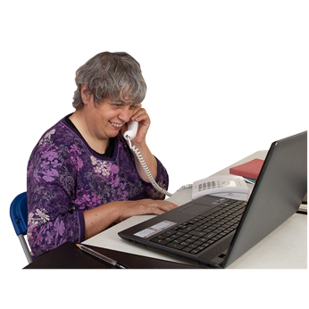

We will talk to you a few days after the meeting to see how you are.


You can do some things to take care of yourself after the meeting.

Some of the ways you might take care of yourself are:

- do something that makes you feel:
- relaxed
- calm.
- ask us for support.
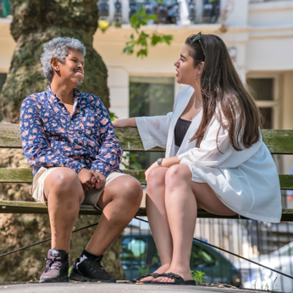
- talk to someone you trust about how you are feeling.

It can be good to talk even if you do not feel like it.

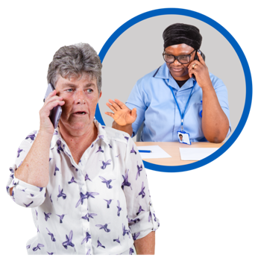
You can also talk to a support service like Lifeline.


Lifeline is a service you can phone / text when you are having a hard time to get:
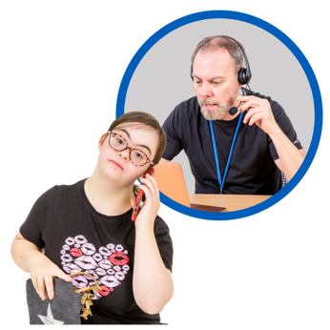
- support
- advice
- someone to talk to.
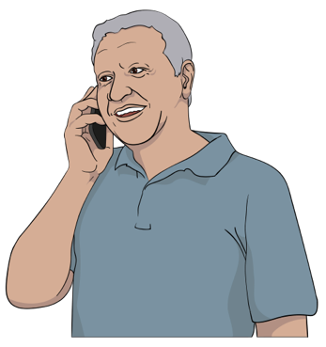

You can call Lifeline on:

0800 543 354

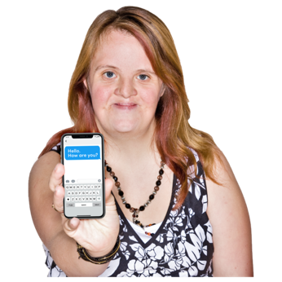
You can text Lifeline at:

4357


It does not cost money to call / text Lifeline.


We will give you a document with information about some support services.

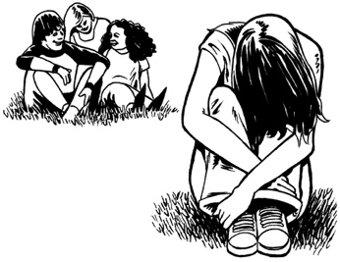
If you are worried about your mental health you should talk to:
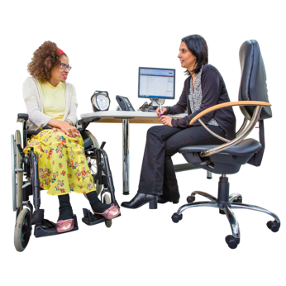
- your family doctor / medical practice
- a mental health service.


Mental health is about how you feel in your mind.

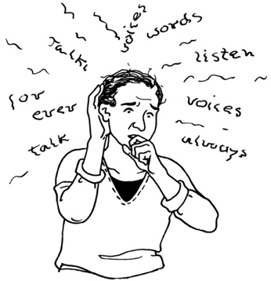
There might be a problem with your mental health if you:
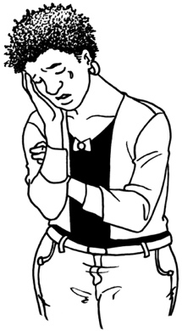
- get really worried about a lot of things
- feel very sad for a long time
- think about hurting yourself a lot.


Call the police on 111 if:
- you are in danger
- someone else is in danger.

How to contact us

You can phone us on:

0800 456 090


If you are in Australia you can phone us on:

1800 456 032

It does not cost money to call these numbers.


You can phone us from:
- 8:30 in the morning

to

- 4:30 in the afternoon.


These times are for the New Zealand time zone.

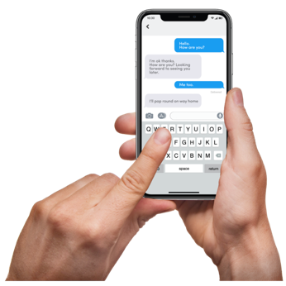
You can text us on:

8328


You can send an email to:

contact@survivorexperiences.govt.nz

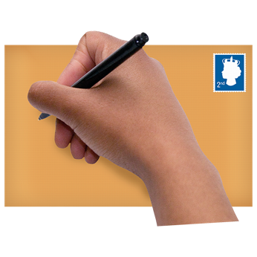
You can write to us at:

Survivor Experiences Service
PO Box 805
Wellington 6140


You can use the New Zealand Relay service to call us.


If you find it hard to use the phone the New Zealand Relay service is for people who are:

- Deaf / hard of hearing


- deafblind

- speech impaired / find it hard to talk.


You can find out more about the New Zealand Relay service at:

www.nzrelay.co.nz


This information has been written by Survivor Experiences Service.

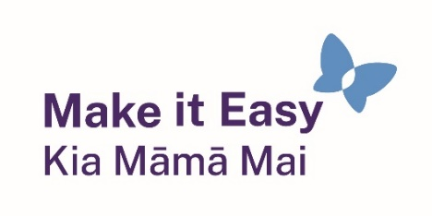
It has been translated into Easy Read by the Make it Easy Kia Māmā Mai service of People First New Zealand Ngā Tāngata Tuatahi.

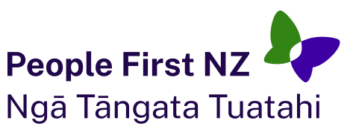
The ideas in this document are not the ideas of People First New Zealand Ngā Tāngata Tuatahi.
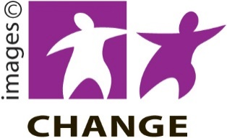
Make it Easy uses images from:

- Changepeople.org


            - Photosymbols.com



- SGC Image Works
- Huriana Kopeke-Te Aho
- T.Wood.

All images used in this Easy Read document are subject to copyright rules and cannot be used without permission.

