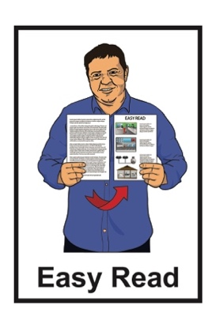
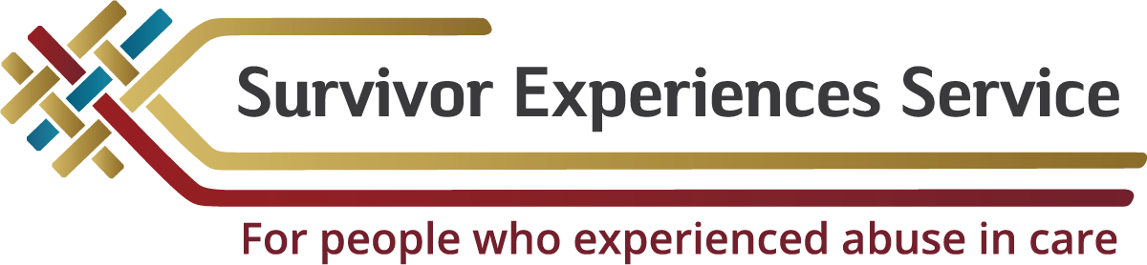

Support for writing about your experience with abuse in care for the Survivor Experiences Service
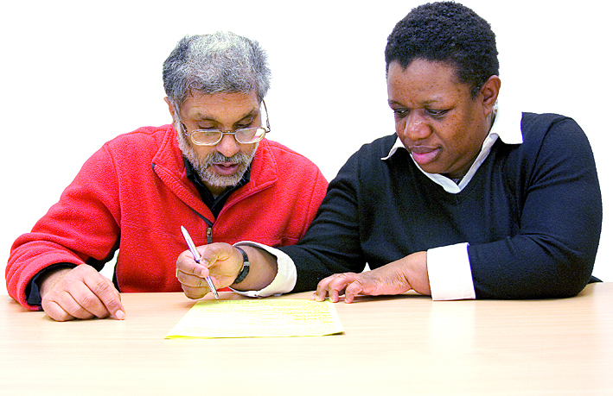

Published: February 2024

Before you start


This document talks about abuse.

This information may upset some people when they are reading it.
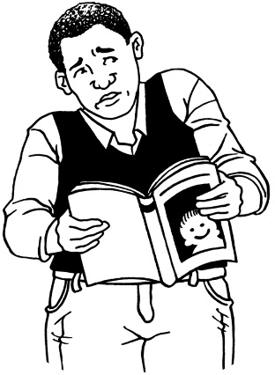


This information is not meant to scare anyone.

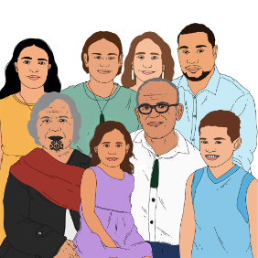
If you are upset after reading this document you can talk to your:
- whānau / family
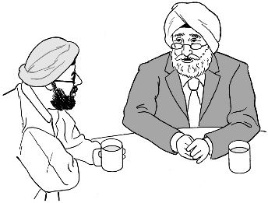
- friends.

What you will find in here

Page number:


What this document is about 3

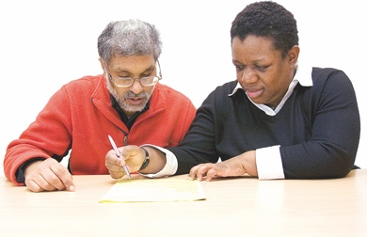
How the literacy support service
works 8

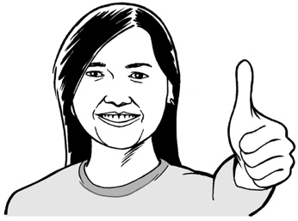
Your wellbeing 11

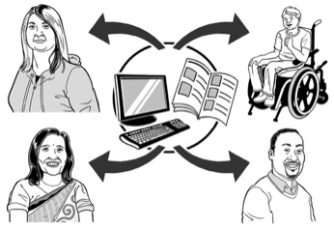
Your information is private 14


Tell us you want to use the
literacy support service 17

How to contact us 26

What this document is about


This document is from the Survivor Experiences Service.
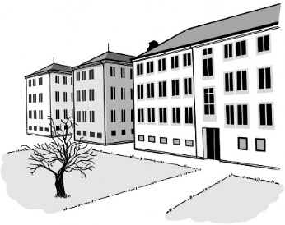

The Survivor Experiences Service is for:
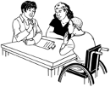
- people who have experienced abuse while in care
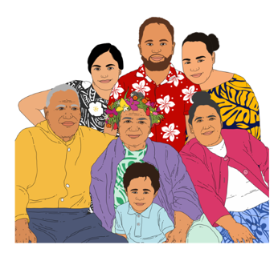
- people to talk about what happened to them
- people and their whānau / families to get the support they need.

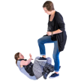
Abuse can be:
- physical – kicking or hitting you
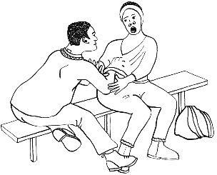
- sexual – doing sexual things to you that you do not want like:
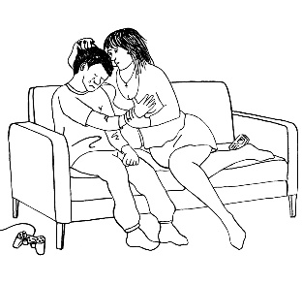
- touching your body or private parts
- kissing you
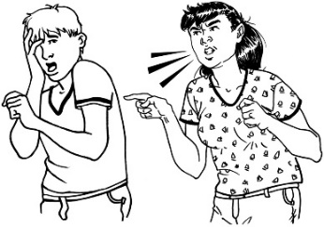
- making you have sex – this is called rape
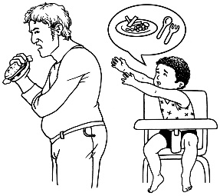
- emotional – yelling or saying things to you that are not nice
- neglect – not giving you the things or care you need.

In this document being in care means that the Government or a faith-based institution was in charge of your care.


Faith-based institutions are run by religious groups like churches.


People who have been through abuse in care are sometimes called survivors.

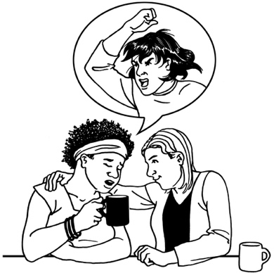
Some people choose to tell us about their experience with abuse in care in a private session.

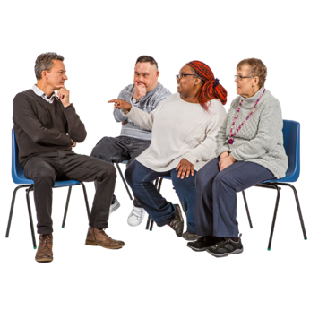
Private session means a meeting. that is just for:
- you
- a few people from the service
- a support person if you want them.


You can also choose to write about what happened to you while you were in care.

This is called a written account.

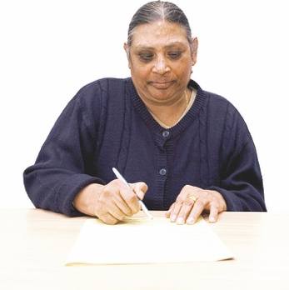
This document is for people who want to:
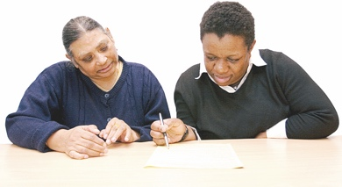
- write about what happened to them
- get support with writing.

The literacy support service can assist with:
- writing
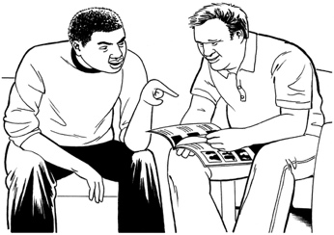
- reading.

This document has information about the literacy support service.


There is also a form you can fill in to tell us you want to use the literacy support service.

How the literacy support service works

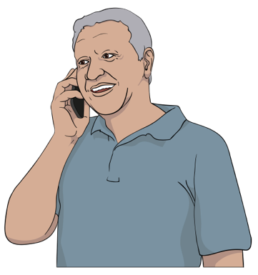
We will tell the literacy support service:
- how to get in touch with you
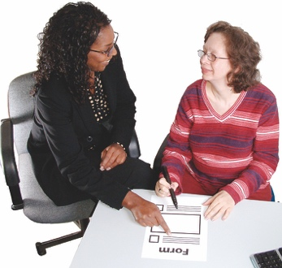
- what you need support with
- what your needs are.

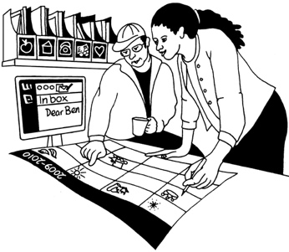
The literacy support service will get in touch with you to make a plan.


Your plan might include:
- where to meet
- when to meet
- what support you want / need
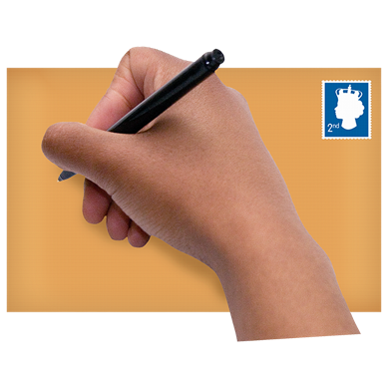
- how long writing about your experiences will take
- how to send your written account to the Survivor Experiences Service.
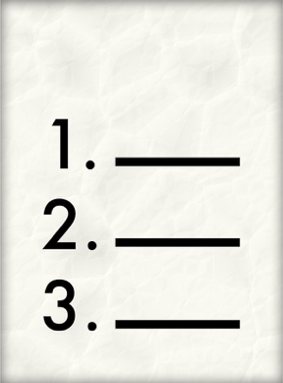

The literacy support service will follow the plan you have made.


You can stop using the literacy support service any time you want.


The literacy support service will get in touch with us if:

- they think keeping on working on your written account would be bad for you
- they cannot get in touch with you
- you do not go to the meetings you have set up with them.

Your wellbeing


Wellbeing means things like:
- feeling okay about ourselves
- taking care of ourselves
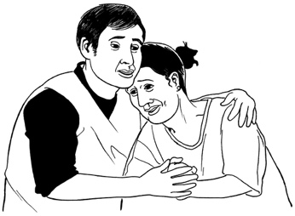
- getting support when we have feelings like being:
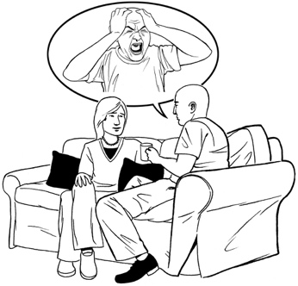
- sad
- worried
- angry.


You might have some very strong feelings when you write about your experiences.

You might feel:

- good that someone has listened to you
- proud about speaking up about what has happened

- glad that it is over
- angry about your abuse

- sad about the things that have happened to you
- a mix of things.

We want to make sure you feel:
- safe
- comfortable.
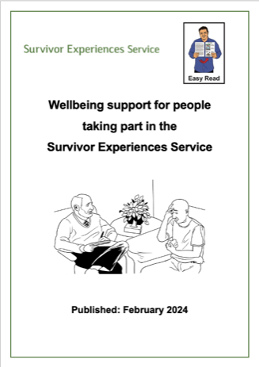

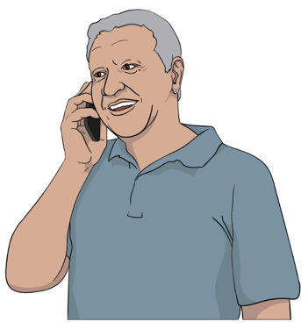
You can find out more about how we can support you in the Easy Read document Wellbeing support for people taking part in the Survivor Experiences Service.

Please let us know if you do not have a copy of this document.

Your information is private

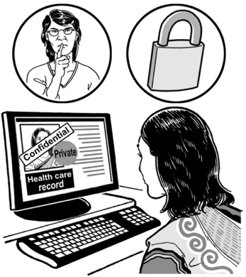
We will keep your information private.

Private means that you are in charge of information about yourself.

It means that you know:

- who can see information about you
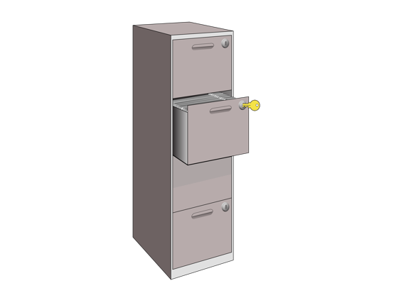
- how information about you will be used
- how information about you will be kept safe.

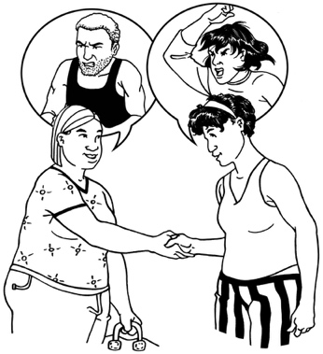
We will tell someone if you are:
- in danger
- being hurt
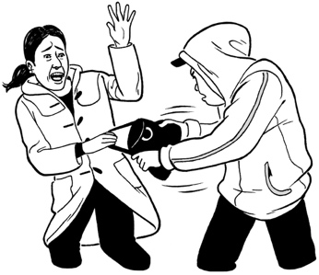
- hurting someone else
- doing something that is against the law.


We will also share your information if the court tells us we have to.


We will not share any more information than we need to.


After you have finished using the literacy support service the Government will keep your information safe.


Very few people will be able to see your information.

Tell us you want to use the literacy support service

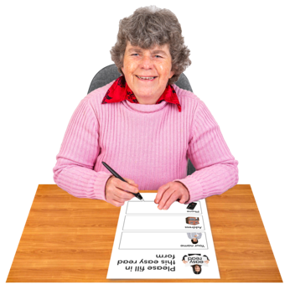
This is to tell you about how to tell us you want to use the literacy support service.


We need some information about you.

Your information will assist us to find you the right support.

You can give us your information by filling out this form.

When you have filled out the form you can send it back to us by:

- post
- email.
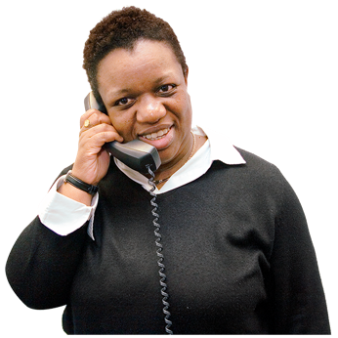

You can also:
- phone us
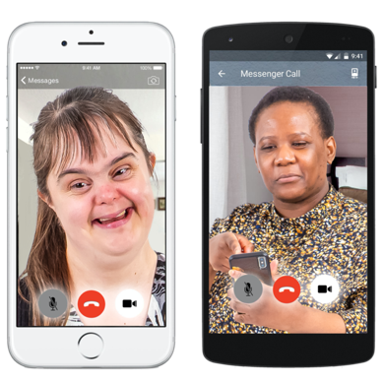
- email us a:
- video
- voice recording.
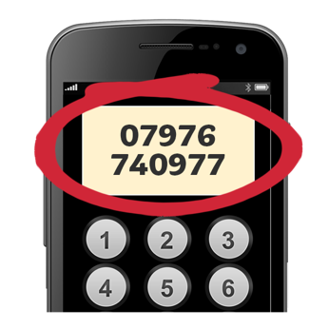

The information about how to get in touch with us is at the end of this document.

Write your answers on the lines:

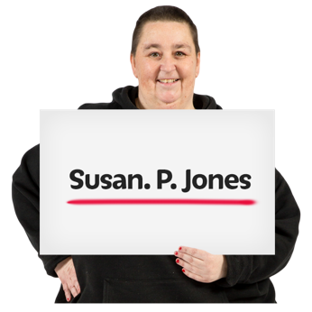
My full name is:

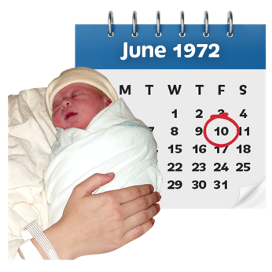
The day I was born on / my date of birth is:

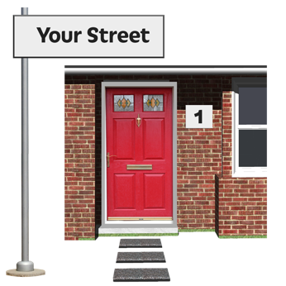
My address where I live is:


Please write on the lines below to tell us why you want to use the literacy support service.
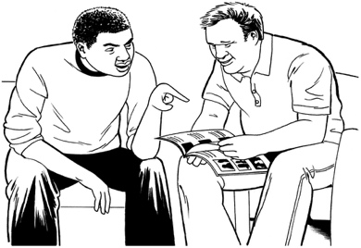

Please write on the lines below to tell us about any support you had to:
- understand this information
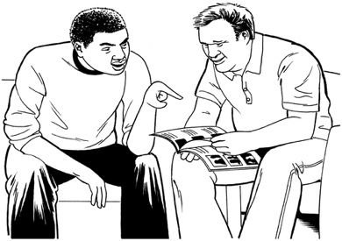
- choose to use the literacy support service.


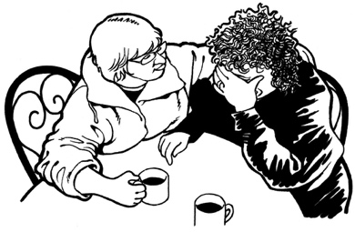
Telling the Survivor Experience Service about what happened to you in care can be hard.

The Wellbeing Service can give you support to make you feel more:
- safe
- comfortable.
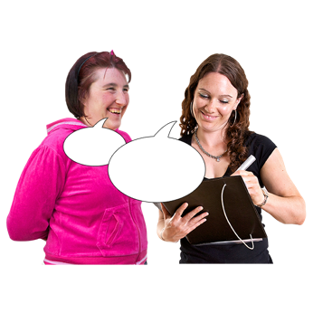

We can tell the Wellbeing Service if you:
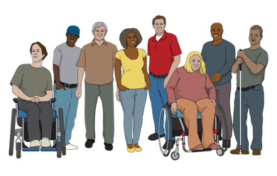
- are disabled
- have other support needs.
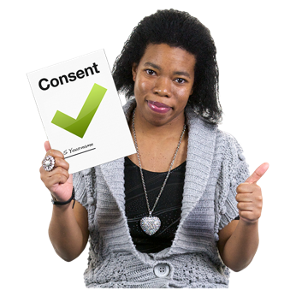

We will only talk to the Wellbeing service if you say that it is okay.


Put a tick in the box that is right for you.


Yes – it is okay to tell the wellbeing support service about my support needs.

No – do not tell the wellbeing support service about my support needs.

There are 3 different learning support services that you can use.

Put a tick in the box beside the service you want to use.

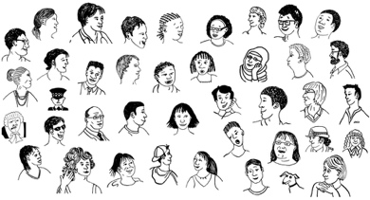
Literacy Aotearoa – this service is for everyone.
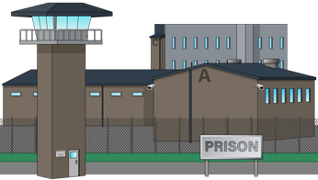
Howard League – this service is for people who are in prison.


Personal Advocacy and Safeguarding Adults Trust – this service is for people with learning disabilities.

I do not mind which service I use.

Put a tick in the box to tell us that you:
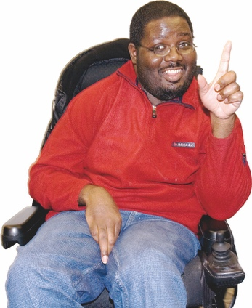
- understand the information
- want to use a literacy support service.

Please sign the form on the line below.

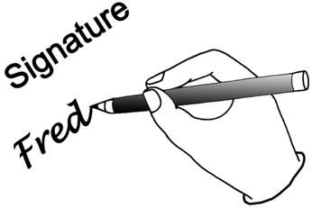
My signature:


The date I signed this document:

How to contact us

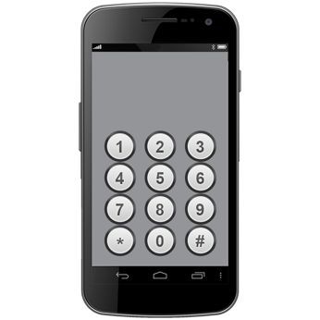
You can phone us on:

0800 456 090


If you are in Australia you can phone us on:

1800 456 032


It does not cost money to call these numbers.


You can phone us from:
- 8:30 in the morning

to

- 4:30 in the afternoon.


These times are for the New Zealand time zone.

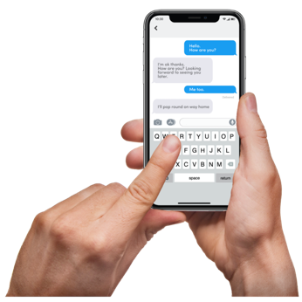
You can text us on:

8328

You can send an email to:

contact@survivorexperiences.govt.nz

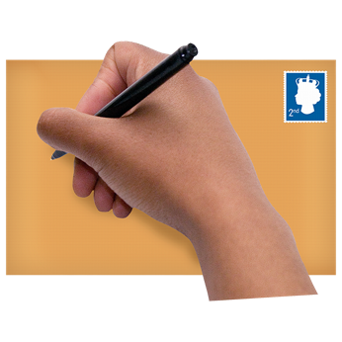
You can write to us at:

Survivor Experiences Service
PO Box 805
Wellington 6140


You can use the New Zealand Relay service to call us.


If you find it hard to use the phone the New Zealand Relay service is for people who are:

- Deaf / hard of hearing

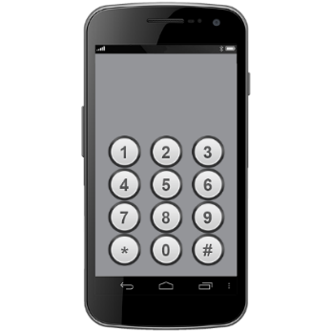
- deafblind

- speech impaired / find it hard to talk.


You can find out more about the New Zealand Relay service at:

www.nzrelay.co.nz

This information has been written by Survivor Experiences Service.

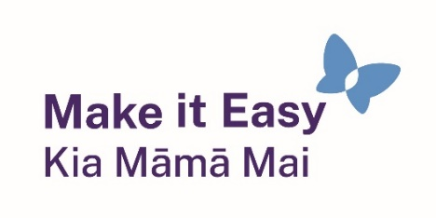
It has been translated into Easy Read by the Make it Easy Kia Māmā Mai service of People First New Zealand Ngā Tāngata Tuatahi.



The ideas in this document are not the ideas of People First New Zealand Ngā Tāngata Tuatahi.

Make it Easy uses images from:


- Changepeople.org


            - Photosymbols.com

- SGC Image Works
- Huriana Kopeke-Te Aho

- T.Wood.

All images used in this Easy Read document are subject to copyright rules and cannot be used without permission.

