
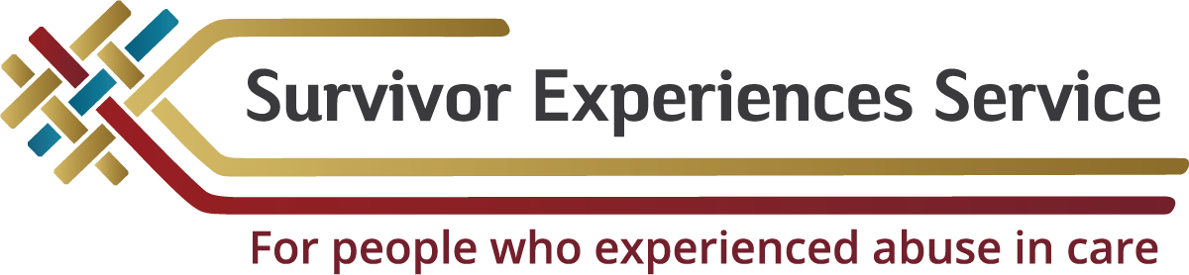

Wellbeing support for people taking part in the
Survivor Experiences Service
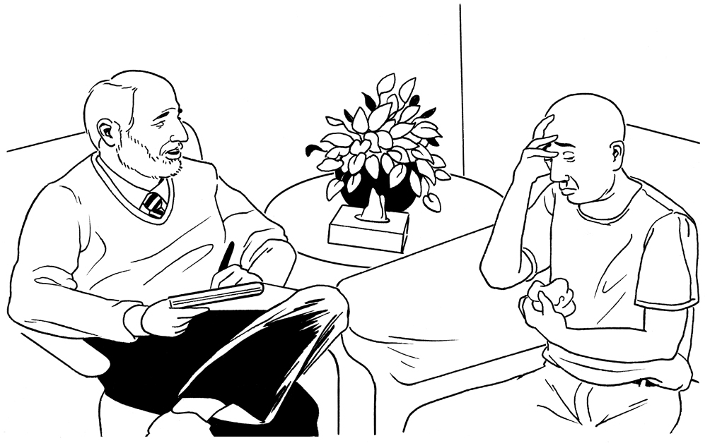

Published: February 2024

Before you start


This is a long document.


It can be hard for some people to read a document this long.

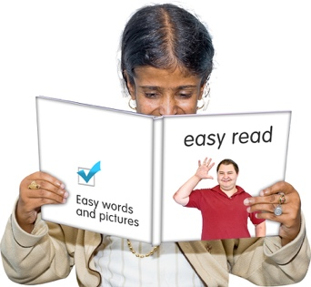
Some things you can do to make it easier are:
- read it a few pages at a time
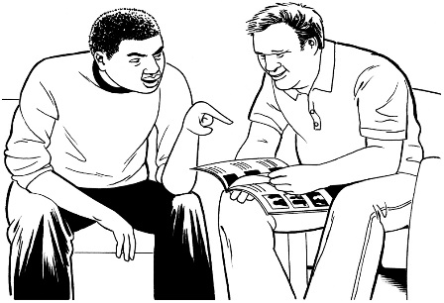
- set aside some quiet time to look at it
- have someone read it with you to support you to understand it.

This document talks about abuse.

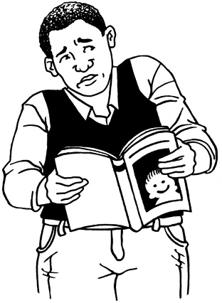

This information may upset some people when they are reading it.

This information is not meant to scare anyone.

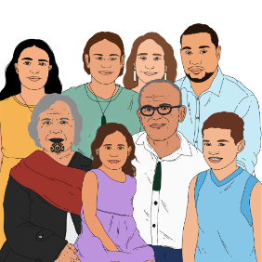
If you are upset after reading this document you can talk to your:
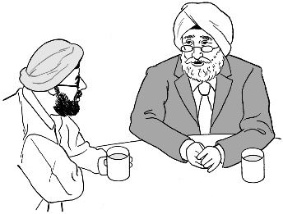
- whānau / family
- friends.

What you will find in here

Page number:


What this document is about 3

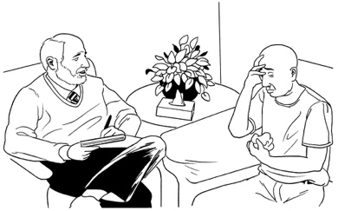
Wellbeing support services 10

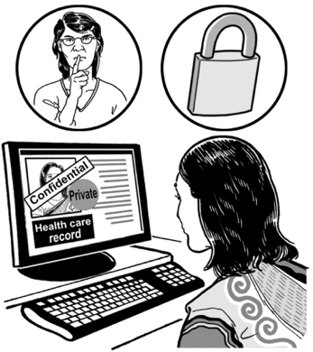
How the wellbeing support
service works 14

Your information is private 18

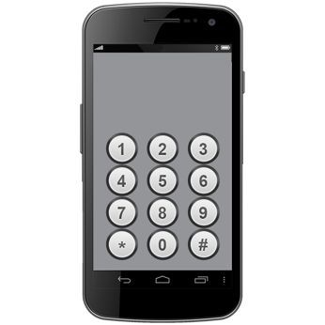
Tell us you want to use the
wellbeing support service 20

How to contact us 35

What this document is about


This document is from the Survivor Experiences Service.


The Survivor Experiences Service is for:
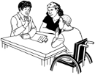
- people who have experienced abuse while in care
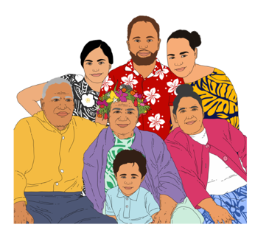
- people to talk about what happened to them
- people and their whānau / families to get the support they need.

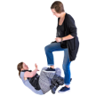
Abuse can be:
- physical – kicking or hitting you
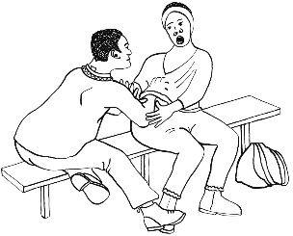
- sexual – doing sexual things to you that you do not want like:
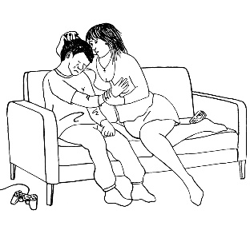
- touching your body or private parts
- kissing you
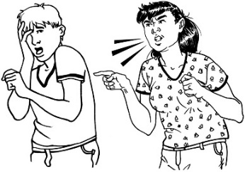
- making you have sex – this is called rape
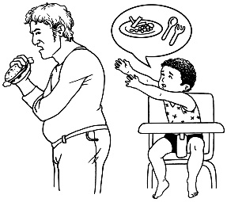
- emotional – yelling or saying things to you that are not nice
- neglect – not giving you the things or care you need.

In this document being in care means that the Government or a faith-based institution was in charge of your care.


Faith-based institutions are run by religious groups like churches.
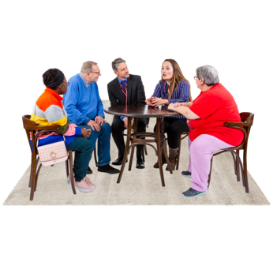

People who have been through abuse in care are sometimes called survivors.


In this Easy Read document when we say the service we mean the Survivor Experiences Service.


This document is about the wellbeing support the Survivor Experiences Service can give you.


Wellbeing means things like:
- feeling okay about ourselves
- taking care of ourselves
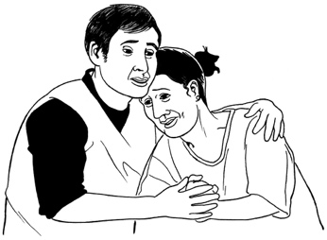
- getting support when we have feelings like being:
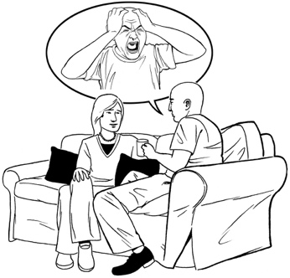
- sad
- worried
- angry.

We will work with you to find the right support for you.

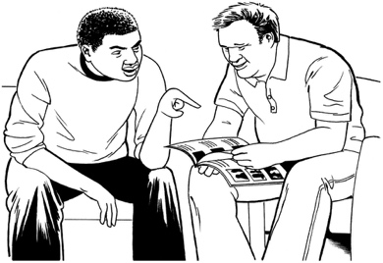
We can give you support like:
- counselling
- mirimiri
- something else that you need.

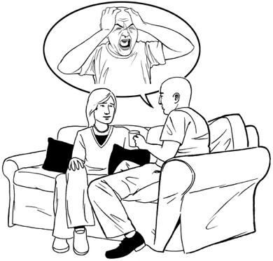
Counselling means talking to a trained person called a counsellor about things that affect you.

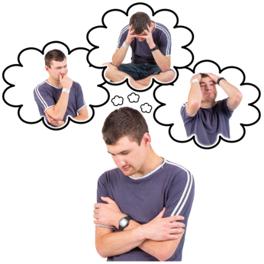
A counsellor can support you to deal with your:
- feelings
- worries.

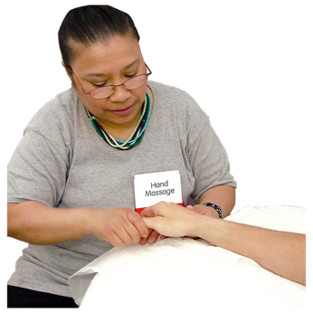
Mirimiri is a kind of massage.

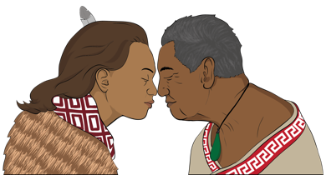
It is something Māori use for healing.

Mirimiri works with your wairua.

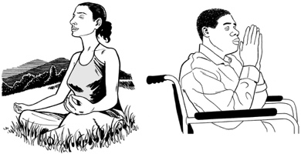
Wairua means your:
- spirit


- emotions / feelings
- mauri / lifeforce.

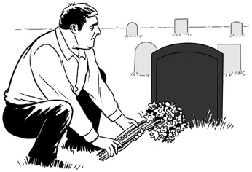
Some people believe it is the part of you that lives on after your body has died.

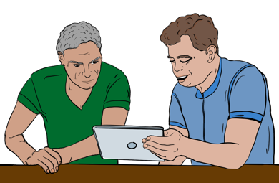
We can find support that works for people who:
- have a learning disability
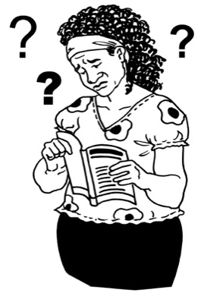
- have trouble:
- understanding things
- remembering things
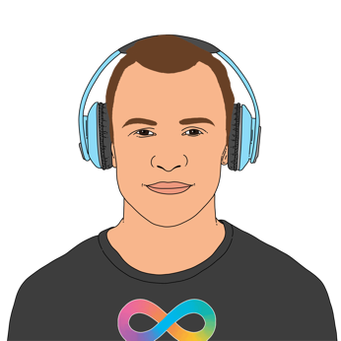
- are neurodiverse.

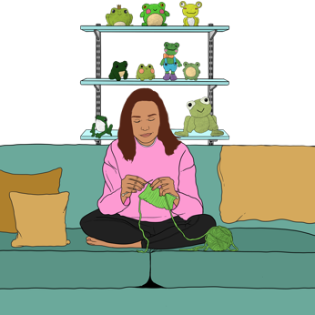
Neurodiverse means having a brain that works differently from people who are not neurodiverse like:
- being autistic
- having ADHD

Wellbeing support services

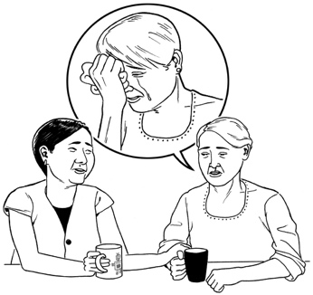
We know that it can be really hard to talk about bad things that have happened to you.

You might have a lot of feelings about the things that have happened to you.

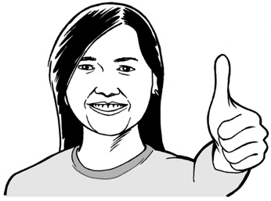
You might feel:
- good that someone has listened to you

- proud about speaking up about what has happened
- glad that it is over.


You might also feel:
- angry about your abuse
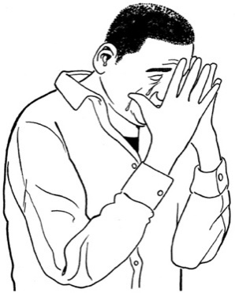
- sad about the things that have happened to you
- a mix of things.


Any way you feel is okay.

We want to make sure that you are okay.


We will give you support so that you can feel:
- safe
- comfortable.


It does not cost money to get support from the survivor Experiences Service.

We will give you 4 to 6 support sessions.

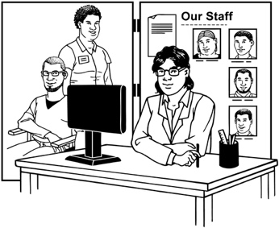
If you need support for longer we can assist you to find the right support.

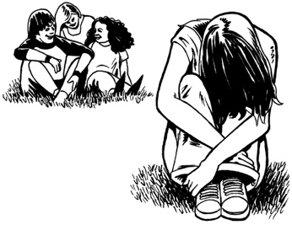
If you are worried about your mental health you should talk to:
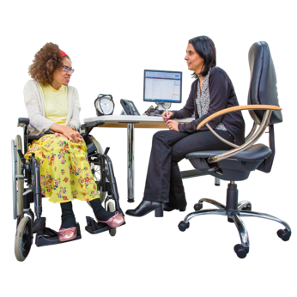
- your family doctor / medical practice
- a mental health service.

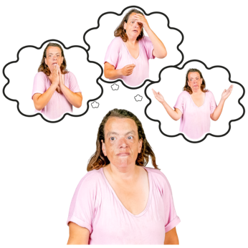
Mental health is about how you feel in your mind.

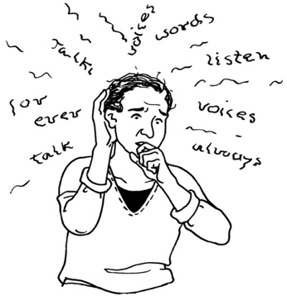
There might be a problem with your mental health if you:
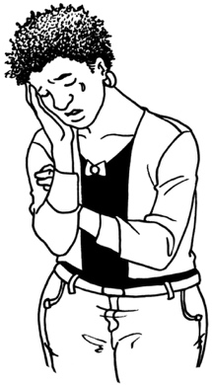
- get really worried about a lot of things
- feel very sad for a long time
- think about hurting yourself a lot.

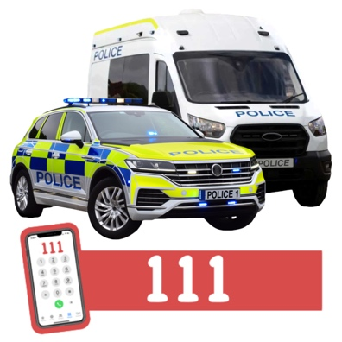
Call the police on 111 if:
- you are in danger
- someone else is in danger.

How the wellbeing support service works

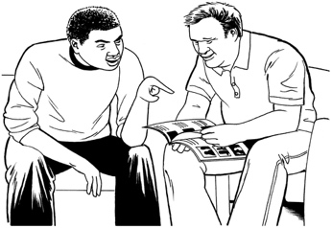
If you choose to use the wellbeing support service we will work with you to find the right support for you.
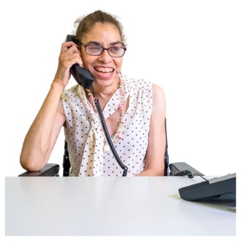

We can tell the wellbeing support service how to get in touch with you.
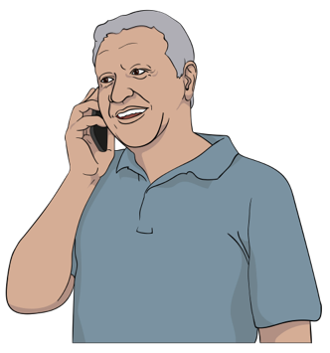

You can also get in touch with the wellbeing support service yourself.
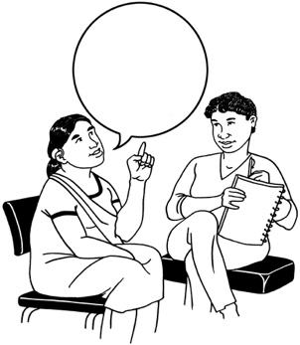
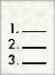

We will tell the wellbeing support service about what you need.

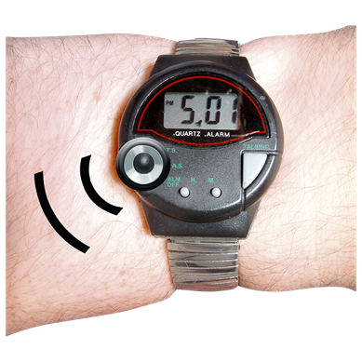
The wellbeing support service will make a time to meet with you.

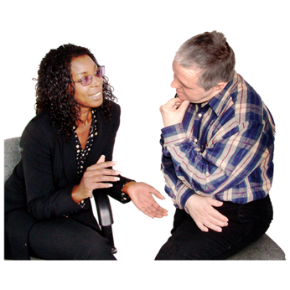
You could meet:
- kanohi-ki-ti-kanohi / in person
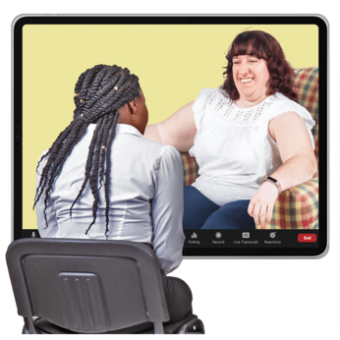
- by video call
- by phone call.

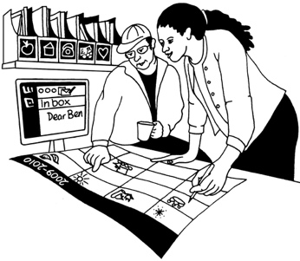
The wellbeing support service will make a plan with you about what will happen in your sessions.


The wellbeing service can sort out transport to your sessions if you need it.

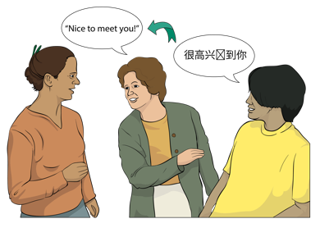
The wellbeing service will also sort out any support you need for things like:

- talking
- hearing
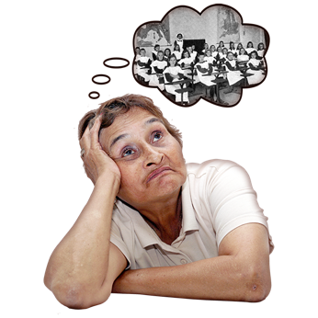
- understanding
- focussing
- remembering.
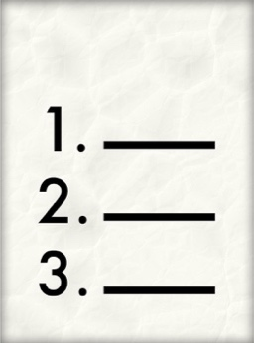

The wellbeing service will follow the plan you have made.


You can stop using the wellbeing service at any time.

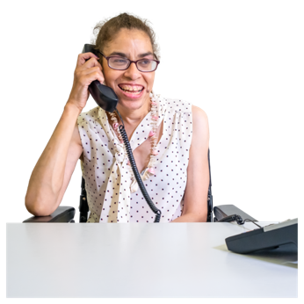
The wellbeing service will get in touch with us if:
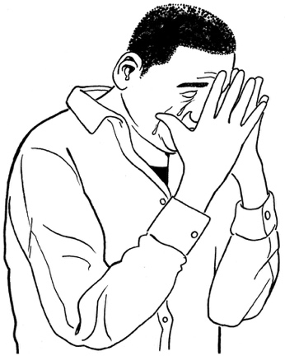
- they think keeping on being part of the Survivor Experiences Service would be bad for you
- they cannot get in touch with you
- you do not go to the meetings you have set up with them.

Your information is private

We will keep your information private.

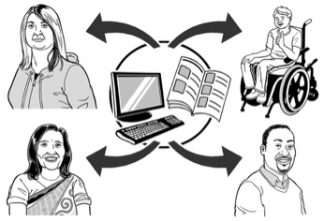
Private means that you are in charge of information about yourself.

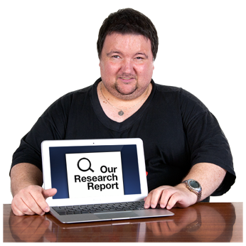
It means that you know:
- who can see information about you
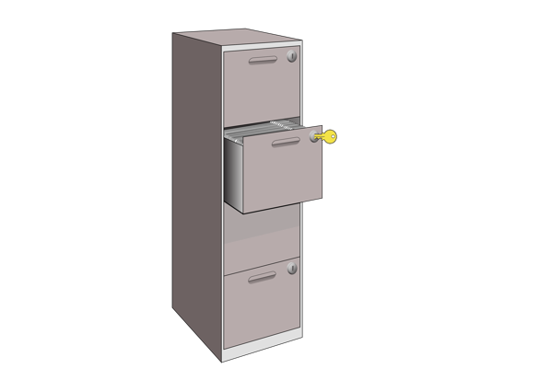
- how information about you will be used
- how information about you will be kept safe.

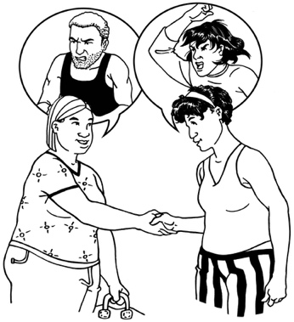
We will tell someone if you are:
- in danger
- being hurt
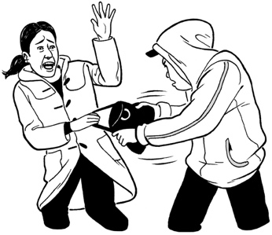
- hurting someone else
- doing something that is against the law.


We will also share your information if the court tells us we have to.


We will not share any more information than we need to.

Tell us you want to use the wellbeing support service

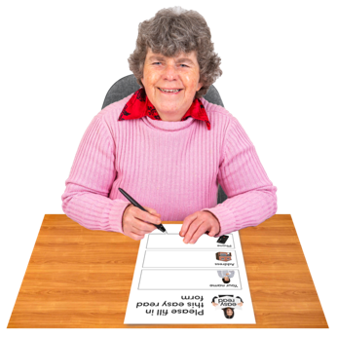
This is to tell you about how to tell us that you want to use the literacy support service.


We need some information about you.

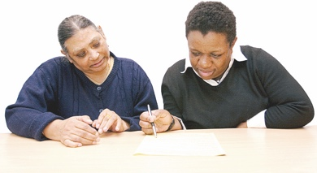
Your information will assist us to find you the right support.

You can give us your information by filling out this form.

When you have filled out the form you can send it back to us by:

- post
- email.
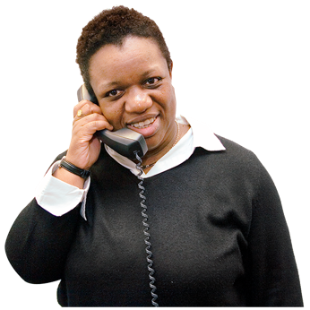

You can also:
- phone us
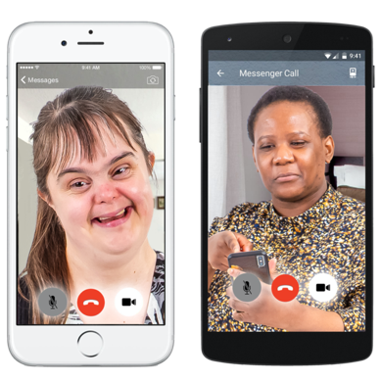
- email us a:
- video
- voice recording.
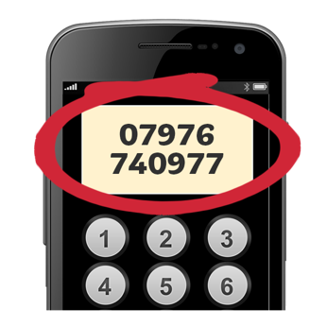

The information about how to get in touch with us is at the end of this document.

Write your answers on the lines:

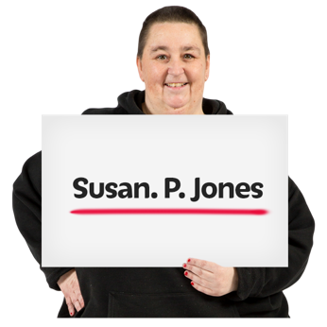
My full name is:

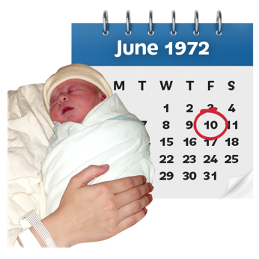
The day I was born on / my date of birth is:

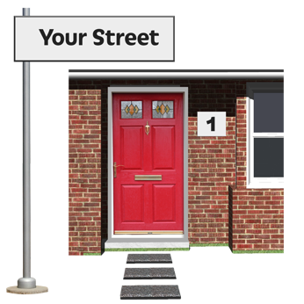
My address where I live is:

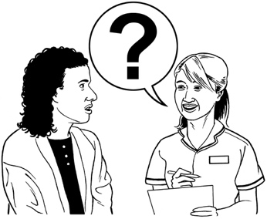
What sort of support do you want / need?

This could be:
- counselling
- mirimiri
- something else.
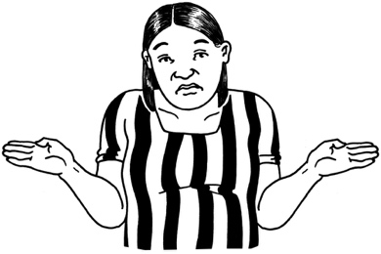

It is okay to say you are not sure what support you want.

Please write on the lines below to tell us the sort of wellbeing support you want.

Are there other things you need / want for your sessions with the wellbeing support service?


You could tell us if:
- you only want to see a counsellor of 1 gender
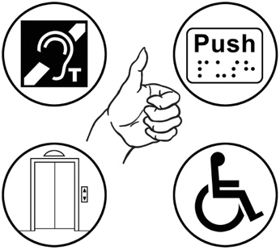
- you have a place you want to meet at
- you have access needs.

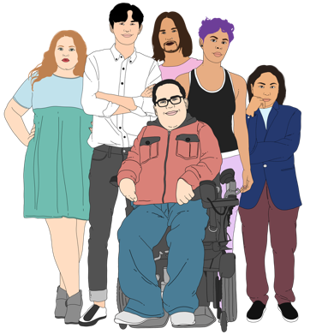
Gender is if you are:
- a woman
- a man
- another gender like nonbinary.

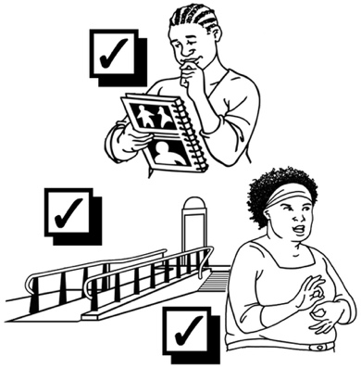
Access means being able to:
- get to a place
- move around a place
- do things in a place.

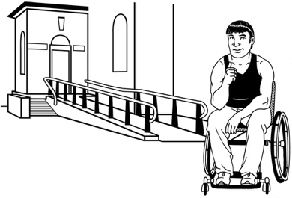
Access needs might be things like:
- a ramp to get into the building
- not having bright lights.

Please write on the lines below to tell us about anything you need for your sessions with the wellbeing support service.
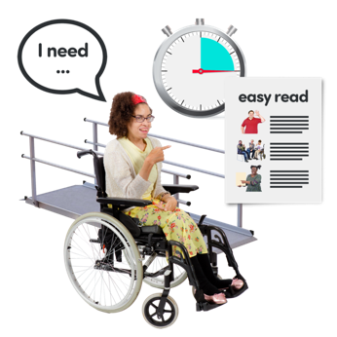

Please write on the lines below to tell us about any wellbeing supports that have worked well for you in the past.

Please write on the lines below to tell us about any wellbeing supports that have not worked well for you in the past.
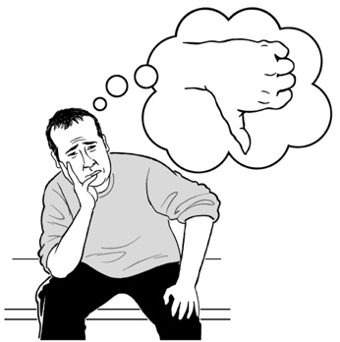

Please write on the lines below to tell us about any support you had to:
- understand this information
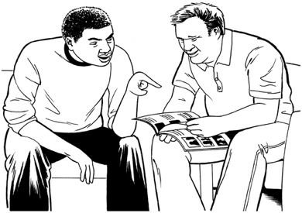
- choose to use the wellbeing support service.
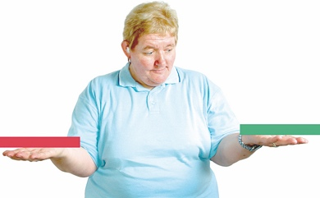

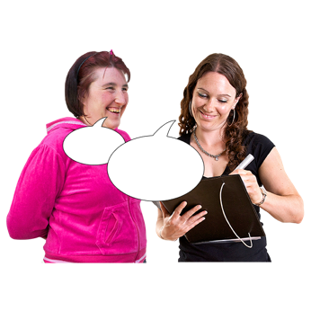
We can tell the wellbeing support service if you:
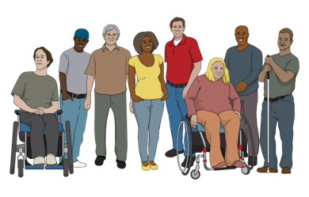
- are disabled
- have other support needs.

This will assist the wellbeing support service to give you the right support.

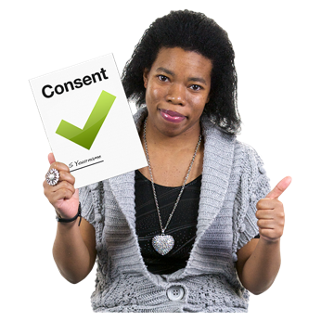
We will only tell the wellbeing service about your disability / support needs if you say it is okay.


Put a tick in the box that is right for you.


Yes – it is okay to tell the wellbeing support service about my disability / support needs.

No – do not tell the wellbeing support service about my disability / support needs.

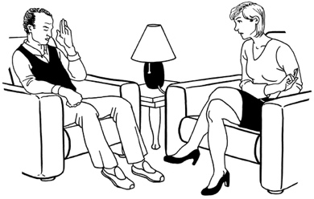
There are 2 different wellbeing support services that you can use.

Put a tick in the box beside the service you want to use.

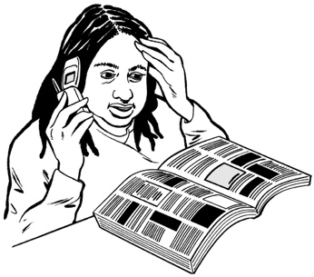

Tautoko Mai – this service will put you in touch with someone near where you live.


Personal Advocacy and Safeguarding Adults Trust – this service is for people with learning disabilities.

I want to use a different service.

If you want to use a different service please use the lines below to tell us:
- the name of the service
- what kind of support they can give
- how to get in touch with them.

Put a tick in the box to tell us that you:
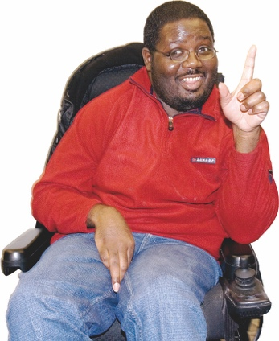
- understand the information
- want to use a wellbeing support service.

Please sign the form on the line below.

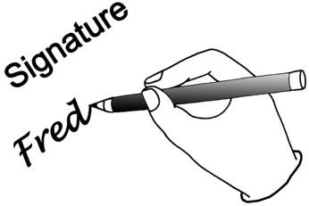
My signature:


The date I signed this document:

How to contact us

You can phone us on:

0800 456 090


If you are in Australia you can phone us on:

1800 456 032


It does not cost money to call these numbers.


You can phone us from:
- 8:30 in the morning

to

- 4:30 in the afternoon.


These times are for the New Zealand time zone.

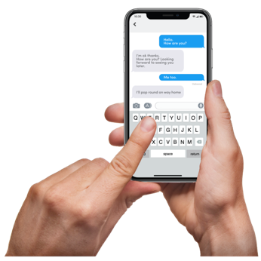
You can text us on:

8328


You can send an email to:

contact@survivorexperiences.govt.nz

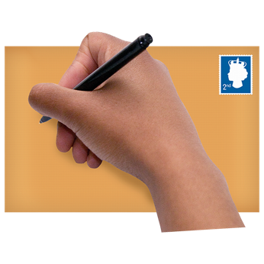
You can write to us at:

Survivor Experiences Service
PO Box 805
Wellington 6140


You can use the New Zealand Relay service to call us.


If you find it hard to use the phone the New Zealand Relay service is for people who are:

- Deaf / hard of hearing

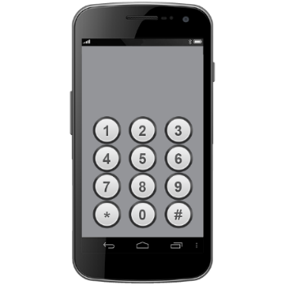
- deafblind

- speech impaired / find it hard to talk.


You can find out more about the New Zealand Relay service at:

www.nzrelay.co.nz

This information has been written by Survivor Experiences Service.

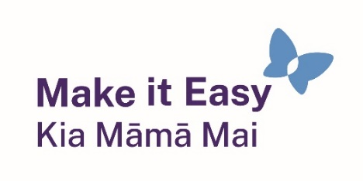
It has been translated into Easy Read by the Make it Easy Kia Māmā Mai service of People First New Zealand Ngā Tāngata Tuatahi.



The ideas in this document are not the ideas of People First New Zealand Ngā Tāngata Tuatahi.

Make it Easy uses images from:


- Changepeople.org


            - Photosymbols.com

- SGC Image Works
- Huriana Kopeke-Te Aho

- T.Wood.

All images used in this Easy Read document are subject to copyright rules and cannot be used without permission.

