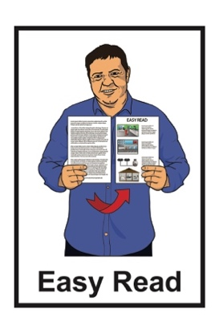

Information about
support services
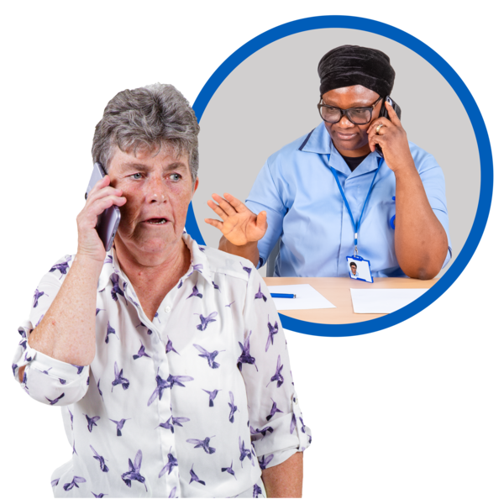

Published: February 2024

Before you start


This is a long document.


It can be hard for some people to read a document this long.

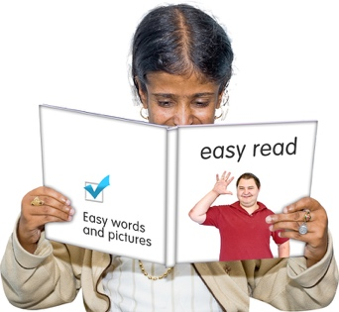
Some things you can do to make it easier are:
- read it a few pages at a time
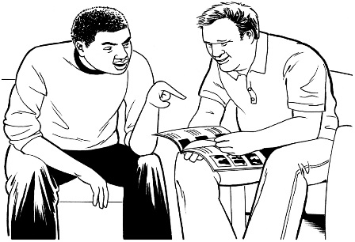
- set aside some quiet time to look at it
- have someone read it with you to support you to understand it.

This document talks about abuse.

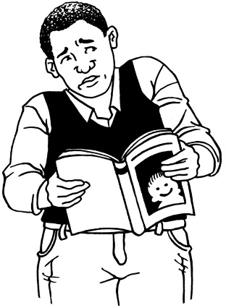

This information may upset some people when they are reading it.

This information is not meant to scare anyone.

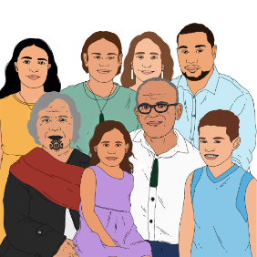
If you are upset after reading this document you can talk to your:
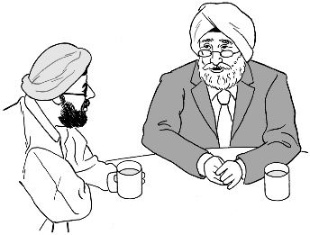
- whānau / family
- friends.

What this document is about

This document is from the Survivor Experiences Service.
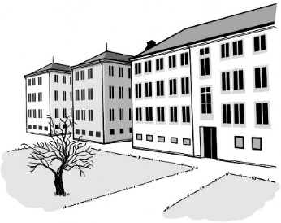

The Survivor Experiences Service is for:
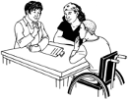
- people who have experienced abuse while in care
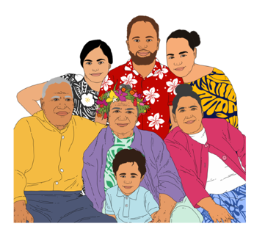
- people to talk about what happened to them
- people and their whānau / families to get the support they need.


Abuse can be:
- physical – kicking or hitting you
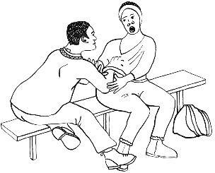
- sexual – doing sexual things to you that you do not want like:
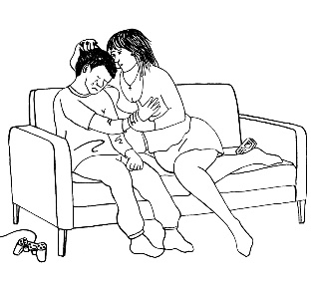
- touching your body or private parts
- kissing you
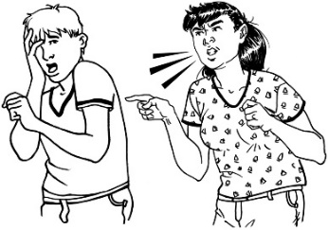
- making you have sex – this is called rape
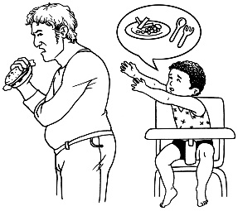
- emotional – yelling or saying things to you that are not nice
- neglect – not giving you the things or care you need.

In this document being in care means that the Government or a faith-based institution was in charge of your care.


Faith-based institutions are run by religious groups like churches.
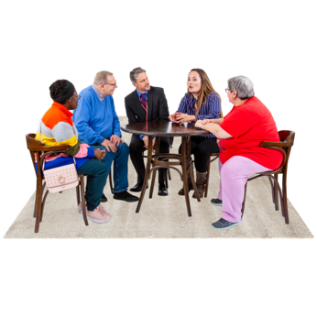

People who have been through abuse in care are sometimes called survivors.


In this Easy Read document when we say the service we mean the Survivor Experiences Service.


You might have a lot of feelings about talking to the service about what has happened to you.
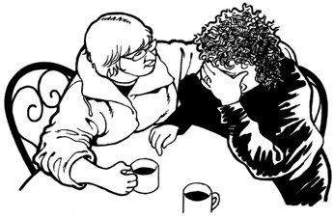

We can give you some support.

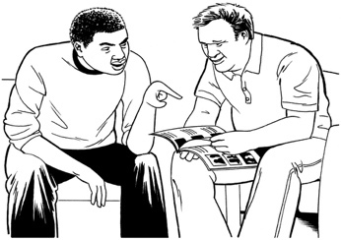
We can assist you to find more support.

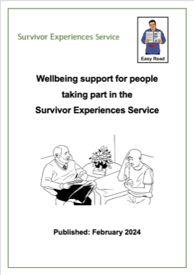
You can find out more about the support we can give you in the Easy Read document Wellbeing support for people taking part in the Survivor Experiences Service.

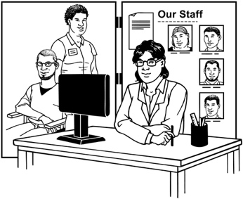
This document has information about support services that can assist if you:

- need more support
- need different support
- need support quickly.

24 / 7 helplines

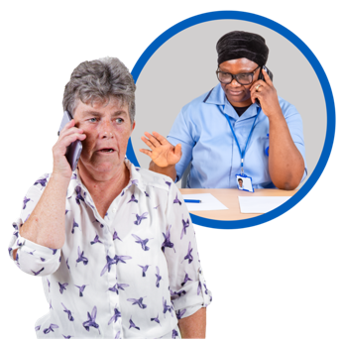
Helplines are services that you can contact for support / advice.



24 / 7 means you can call these helplines any time:
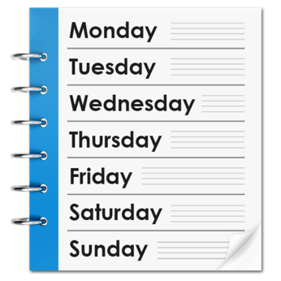
- 24 hours a day
- 7 days a week.


It does not cost money to call these helplines.

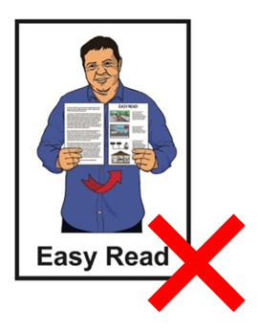
The information on these websites is not in Easy Read.


The information in this document is for people who are in Aotearoa New Zealand.

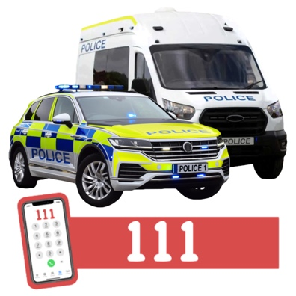
Call the police on 111 if:
- you are in danger
- someone else is in danger.

Depression Helpline
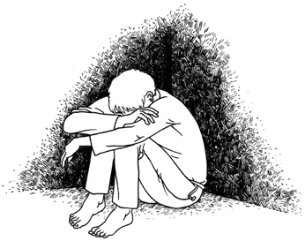

The Depression Helpline can give you support with:

- depression – feeling very sad for a long time
- anxiety – getting really worried about a lot of things.


The Depression Helpline website has a lot of information about:
- getting support
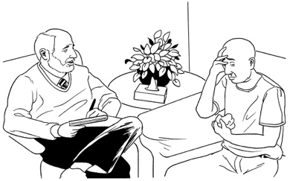
- taking care of yourself.

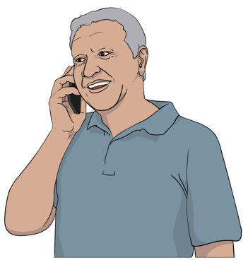
You can phone the Depression Helpline on:

0800 111 757


You can text the Depression Helpline at:

4202


The Depression Helpline website is:

www.depression.org.nz

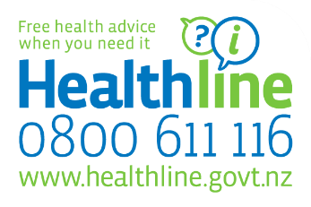
Healthline

You can call Healthline if you are:
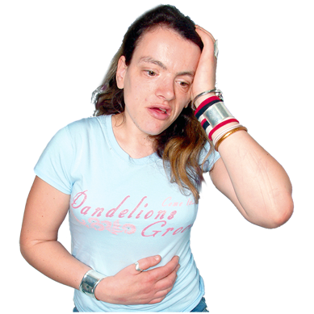
- unwell
- hurt
- worried about your health.

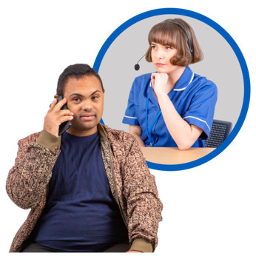
When you call Healthline you will talk to a nurse.

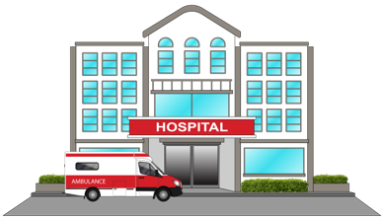
The nurse at Healthline can:
- tell you if you need a doctor / hospital
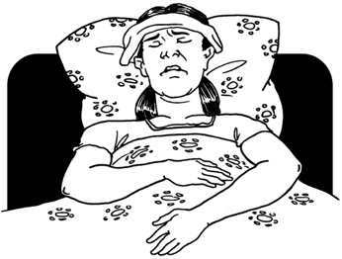
- tell you how to take care of yourself.

You can phone Healthline on:

0800 611 116

The website for Healthline is:

http://tinyurl.com/4zd3m4uj

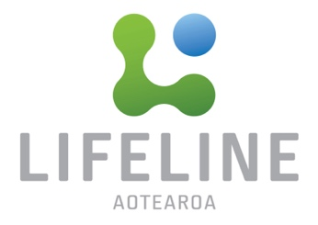

Lifeline

You can phone / text Lifeline when you are having a hard time to get:
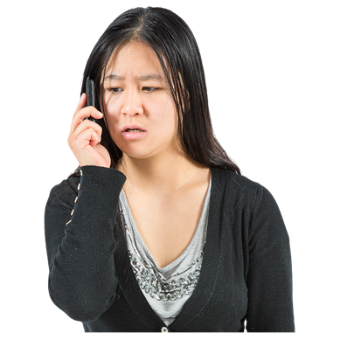
- support
- advice
- someone to talk to.

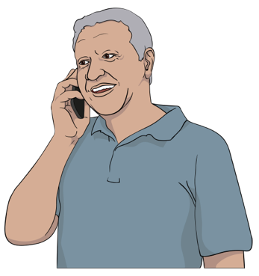
You can call Lifeline on:

0800 543 354

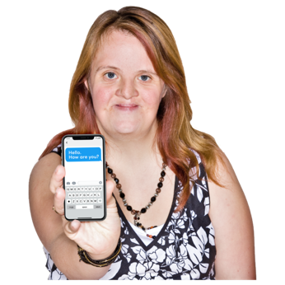
You can text Lifeline at:

4357

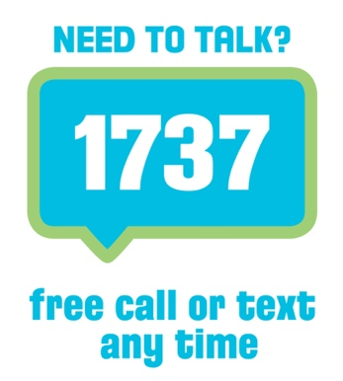

Need to Talk

Need to Talk lets you talk to a counsellor.

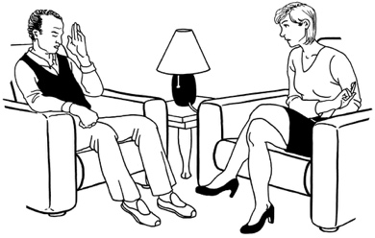
Counsellor means someone who is trained to support people going through a hard time.


You can call Need to Talk if you are feeling:
- stressed
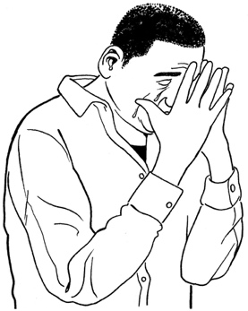
- worried
- sad

You can phone / text Need to Talk on:

1737

The website for Need to Talk is:

www.1737.org.nz

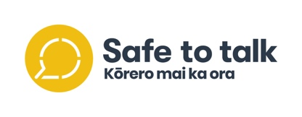
Safe to Talk

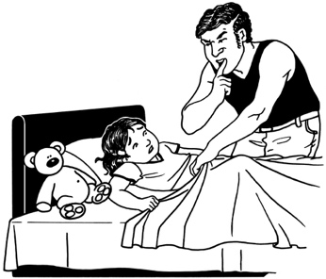
Safe to Talk is for people who have experienced sexual abuse.

Sexual abuse means doing sexual things to you that you do not want like:
- touching your body or private parts
- kissing you
- making you have sex – this is called rape.

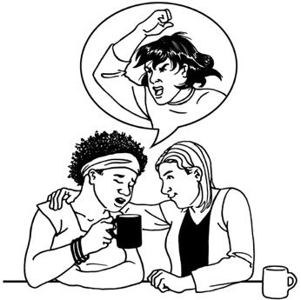
You can call Safe to Talk to:
- talk about what has happened to you
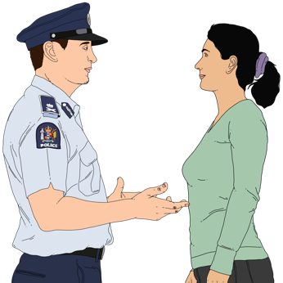
- ask questions about sexual abuse
- get support to tell the police about what has happened
- find out how to get more support.

You can phone Safe to Talk on:

0800 0440334

You can text Safe to Talk at:

4334

The website for Safe to Talk is

www.safetotalk.nz

Suicide Crisis Helpline

Suicide is when you kill yourself because life feels too hard.

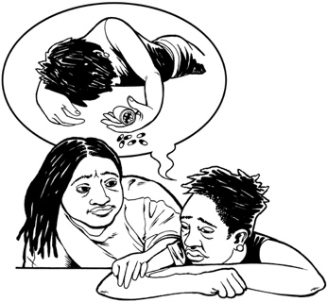
You can call the Suicide Crisis Helpline if:
- you are thinking about suicide
- someone you know is thinking about suicide.

Call 111 if:
- you are in danger
- someone else is in danger
- someone is badly hurt.

You phone the Suicide Crisis Helpline on:

0508 828 865

The website for the Suicide Crisis helpline is:

http://tinyurl.com/bdfbrmp8

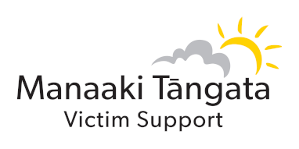
Victim Support

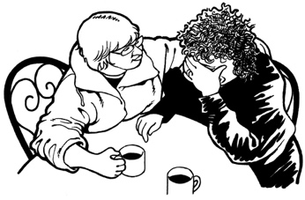
Victim Support can give you support if something bad has happened to you like:
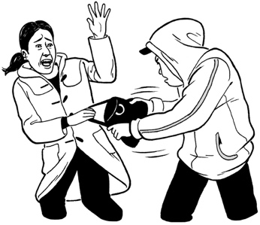
- a crime
- suicide of someone you know.
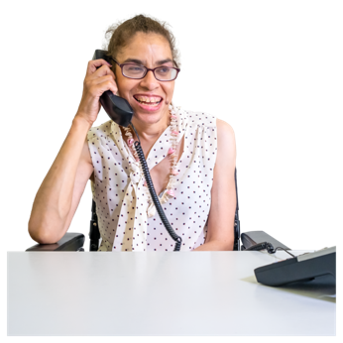

They will talk to you to find out what sort of support you need.

You can phone Victim Support on:
0800 842 846

The website for Victim support is:

www.victimsupport.org.nz

Some other services

These services can also give you support.


Some of them give support for just 1 thing.

You might only be able to call them at some times.


ACC Sensitive Claims Helpline

ACC Sensitive Claims supports people who have experienced sexual abuse with:
- counselling
- money if you can not work because of what has happened.

You can phone ACC Sensitive Claims Helpline to find out more information on:

0800 735 566

The website for ACC Sensitive Claims is:

www.findsupport.co.nz

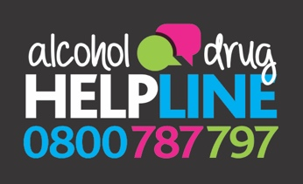
Alcohol and Drug Helpline

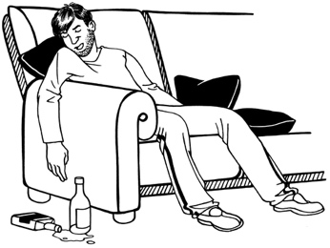
You can call the Alcohol and Drug Helpline if:
- you are worried about how you are using:
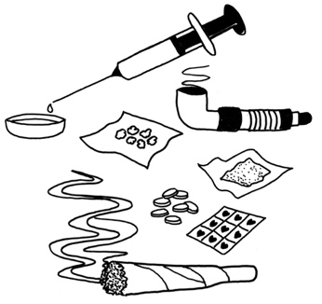
- alcohol
- drugs
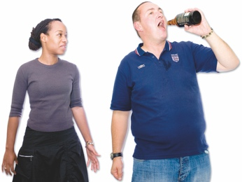
- are worried about someone you know
- want to learn how to keep safe with alcohol / drugs.

When you call you the Alcohol and Drug Helpline you will speak to a counsellor who can:
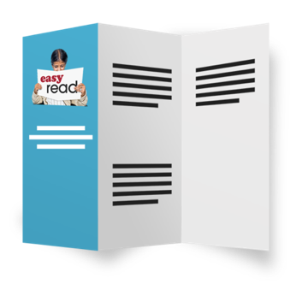
- give you support
- give you information / advice
- assist you to find support where you live.

You can phone the Alcohol and Drug Helpline on:

0800 787 797

You can text the Alcohol and Drug Helpline at:

8681

The website for the Alcohol and Drug Helpline is:

www.alcoholdrughelp.org.nz



Anxiety Phone Line

You can call the Anxiety Phone Line if you are feeling:
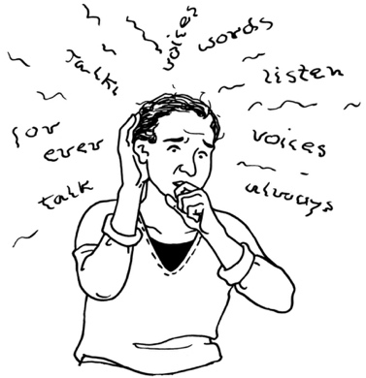
- anxious
- worried
- stressed


When you call the Anxiety Phone Line you will talk to someone who will:
- listen to how you are feeling
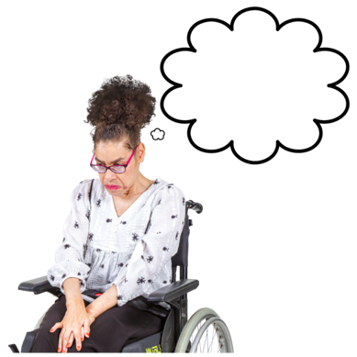

- support you to feel calmer
- give you information about managing anxiety.

You can phone the Anxiety Phone Line on:

0800 269 4839

The website for the Anxiety Phone Line is:

www.anxiety.org.nz

Family Services Helpline

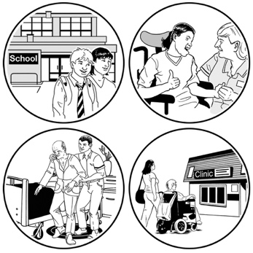
Family Services Helpline has information about support services for lots of different things.


You can search the website to find support where you live.

You can phone the Family Services Helpline on:

0800 211 211

The website for the Family Services Helpline is:

http://tinyurl.com/yjshd3wn


Gambling Helpline


Gambling means paying money for a chance of winning more money.


Gambling can be things like:
- buying a lottery ticket
- betting on a horse race
- playing a pokie machine.


You can call the gambling Helpline if you:
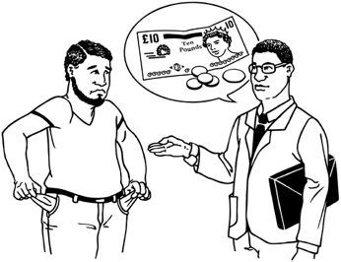
- are worried about the way you are gambling.
- are worried about someone else.


The Gambling Helpline can support you to:

- change how you gamble
- sort out problems gambling has caused for you.

You can phone the Gambling Helpline on:

0800 654 655

You can text the Gambling Helpline at:

8006

The website for the Gambling Helpline is:

www.gamblinghelpline.co.nz


Tautoko Tāne

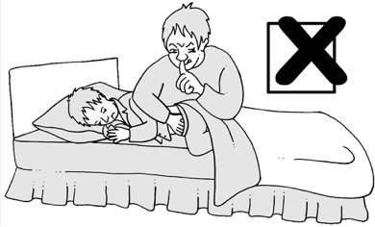
Tautoko Tāne gives support to men who have experienced sexual abuse.

They can tell you how to find support where you live.

The website for Tautoko Tāne is:

www.tautokotane.nz



OUTline

OUTline gives support to people who are LGBTTQIA+

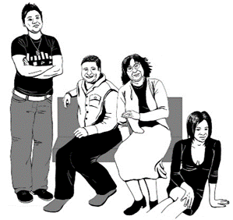
LGBTTQIA+ stands for people who are:
- Lesbian
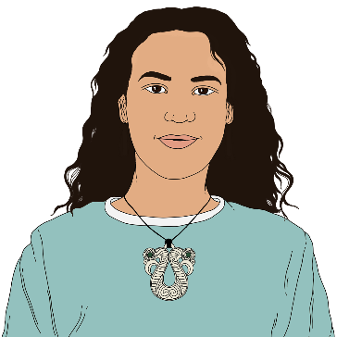
- Gay
- Bisexual
- Transgender
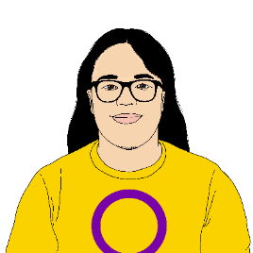
- Takatāpui
- Queer
- Intersex

- Asexual
- + is for other people who fit in similar groups.


You can call OUTline to talk about any worries you have about your:
- gender
- sexuality.

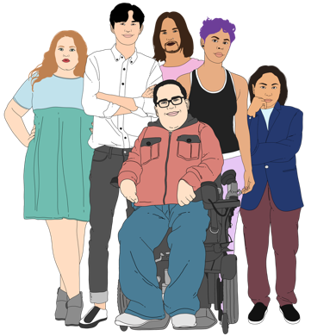
Gender is if you are:
- a woman
- a man
- another gender like nonbinary.

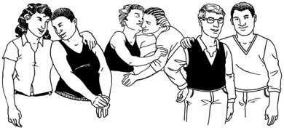
Sexuality is about what gender people you:
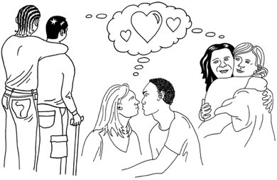
- are attracted to
- want to have sex with.

You can phone OUTline on:

0800 688 5463

The website for OUTline is:

www.outline.org.nz

Rape Crisis

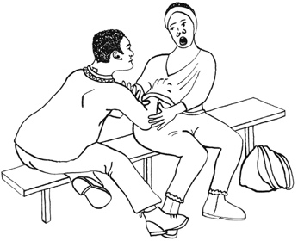
Rape Crisis gives support to people who have experienced sexual abuse.

You can phone Rape Crisis on:

0800 883 300

Samaritans

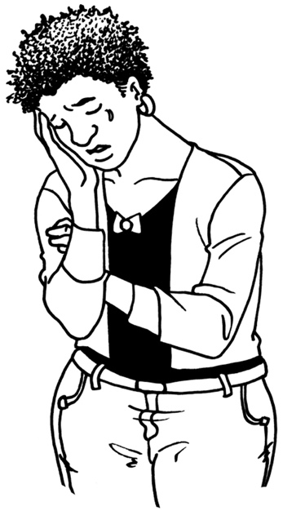
You can call Samaritans if you are feeling:
- lonely
- sad
- worried
- like you want to hurt yourself.


When you call Samaritans you will talk to someone who can:
- listen to you
- support you to feel better.

You can phone Samaritans on:

0800 726 666
The website for Samaritans is:

www.samaritans.org.nz

Skylight

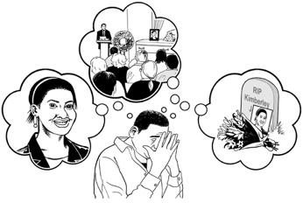
Skylight can give you support if you are going through a hard time like:
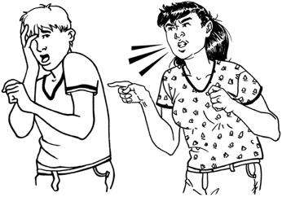
- someone you love has died
- you have been abused
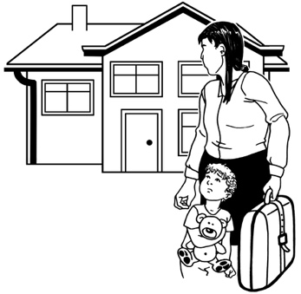
- your marriage / family has broken up
- your children are having a hard time.

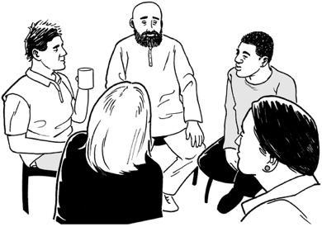
Skylight does:
- counselling
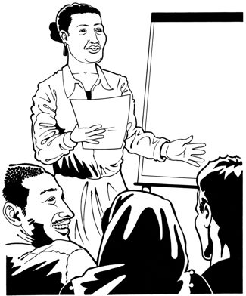
- support groups
- courses.

You can phone Skylight on:

0800 229 100

The website for Skylight is:

www.skylight.org.nz

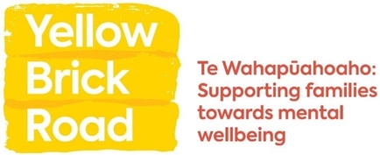
Yellow Brick Road

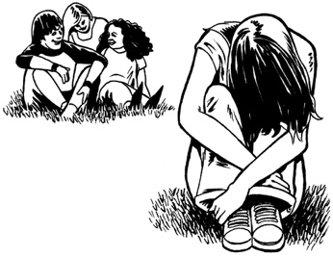
Yellow Brick Road can support you if someone in your whānau / family is having a hard time with their mental health.

You can phone Yellow Brick Road on:

0800 732 825


Youthline

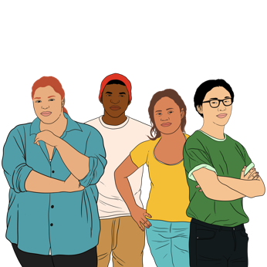
Youthline is for:
- young people aged 12 to 14 years

- people who are supporting young people like:
- parents

- teachers
- friends

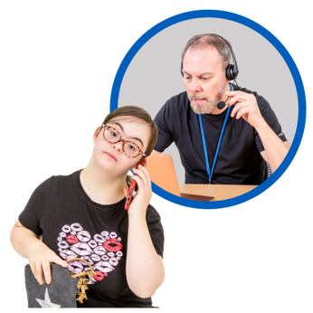
Youthline does:
- counselling
- advice
- mentoring.


Mentoring means working with someone to:
- think about what you want to do
- make a plan.

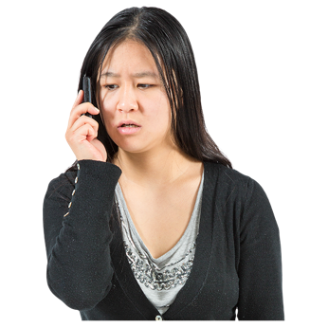
You can phone Youthline on:

0800 376 633


You can email Youthline at:

talk@youthline.co.nz

How to contact us

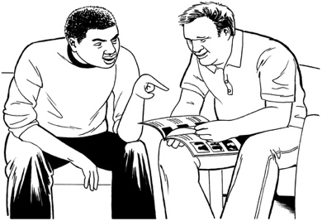
You can talk to us about the support you need while you are with the Survivor Experiences Service.

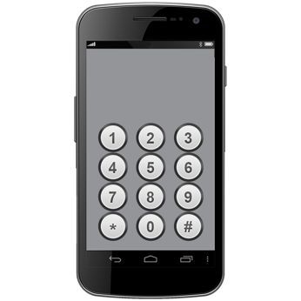
You can phone us on:

0800 456 090


If you are in Australia you can phone us on:

1800 456 032


It does not cost money to call these numbers.


You can phone us from:
- 8:30 in the morning

to

- 4:30 in the afternoon.


These times are for the New Zealand time zone.

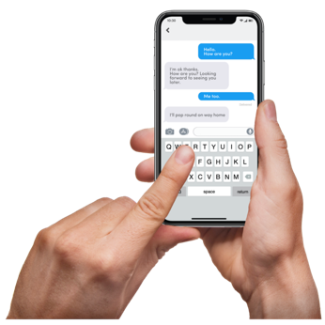
You can text us on:

8328

You can send an email to:

contact@survivorexperiences.govt.nz

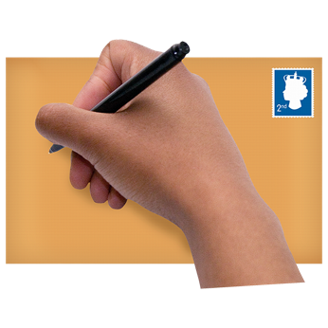
You can write to us at:

Survivor Experiences Service
PO Box 805
Wellington 6140

You can use the New Zealand Relay service to call us.


If you find it hard to use the phone the New Zealand Relay service is for people who are:

- Deaf / hard of hearing

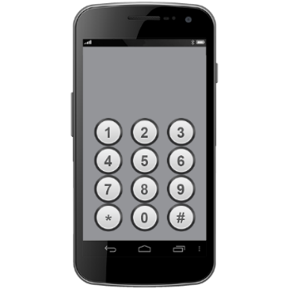
- deafblind

- speech impaired / find it hard to talk.


You can find out more about the New Zealand Relay service at:

www.nzrelay.co.nz

This information has been written by Survivor Experiences Service.

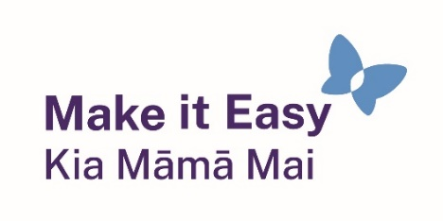
It has been translated into Easy Read by the Make it Easy Kia Māmā Mai service of People First New Zealand Ngā Tāngata Tuatahi.

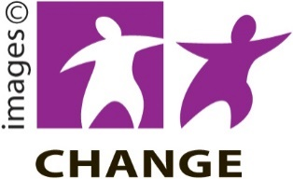
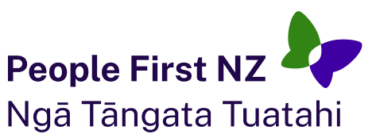
The ideas in this document are not the ideas of People First New Zealand Ngā Tāngata Tuatahi.

Make it Easy uses images from:


- Changepeople.org


            - Photosymbols.com

- SGC Image Works
- Huriana Kopeke-Te Aho

- T.Wood.

All images used in this Easy Read document are subject to copyright rules and cannot be used without permission.

