# Information about your Private Session

# He mōhiohio mō tō mahinga muna

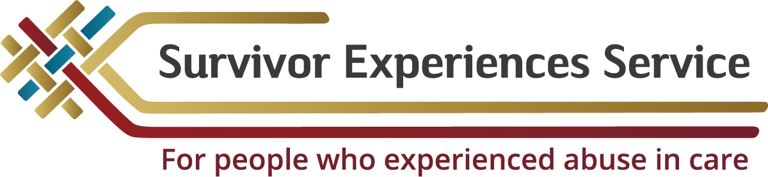

### Kia ora, Mālō, Talofa, Kia Orana, Bula and hello.

#### Thank you for coming forward to share your experience of abuse.

**Information for Survivors**

He mōhiohio mā ngā Whakarauora

We know the mana and courage it takes to come forward and speak with us. We will treat you and the information you share with us confidentially and with respect.

The following information provides details about what to expect when you come to the Survivor Experiences Service | Ratonga Wheako Mōrehu, what you can do to prepare, and what will happen to the information that you provide.

###### Getting Ready for the Private Session

Te Whakarite mō tō Mahinga Muna

Wellbeing **|** Oranga

We offer you free support and counselling when you come to the Service. A Wellbeing Support person can contact you before the session to check that you’re ok.

**Private Sessions**

He mahinga muna

You have been invited to a private session to share your experience of abuse in care, in your own words.

You will meet three people from the Survivor Experiences service, they will be:

* *A Kaitakawaenga who will listen to your story, and may ask some questions or Pātai to help our understanding.*
* *A Session Facilitator who, with your permission will take notes, and make an audio recording; and*
* *A Wellbeing/Oranga Support who will be available to support you before, during and after your session.*

**Preparing for your Private Session**

E whakarite ana mō tō mahinga muna

You will have about 60-90 minutes to meet with the Kaitakawaenga.

To prepare for your private session, it may help to think about what you would like to say. There are lots of things you might want to say, and so if you want to, you can write it down. If you want help with that, ring the Contact and Support team.

Here are some questions which may help you:

* *What was your childhood like?*
* *Why were you put in care?*
* *What happened to you in care?*
* *Who abused you?*
* *Did you tell anyone about what was happening to you?*
* *What were the impacts of what happened to you in care?*
* *How could you have been protected from the abuse?*
* *Have you applied for compensation or an apology?*

**Day of Private Session**

Te rā o te mahinga muna

Your Session Facilitator will meet you on the day of your private session. Your Wellbeing Support will be available for you to speak to before and after your private session. This person is also available during your session if you want to speak with them.  
  
Before the Kaitakawaenga joins you, the Session Facilitator will go over the consent form with you and ask you to sign it. The consent form ensures that you know your rights. A copy of the consent form is included with this pack.  
  
When you feel ready to talk, the Kaitakawaenga will join you and introduce themselves. Before starting the audio recorder, the Kaitakawaenga will ask if you are ready to start and remind you that the session will be recorded. If you decide that you do not want the session recorded, you can still have your session.  
  
You choose how much you want to say. Sometimes the Kaitakawaenga may ask questions to make sure they are clear about what you are saying. Always remember, you do not have to answer or speak about anything you don’t wan

**After your private session**

I muri iho i tō mahinga muna

After your session, there is wellbeing support available if you would like it. They are there if would like to talk with them or if you would like information or support about how to process your feelings over the next days and weeks.

###### What does the process look like?

He pēhea te āhua o te tukanga?

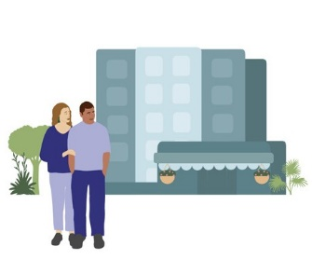

**Step 1**

The survivor and their support person(s) arrive at the venue

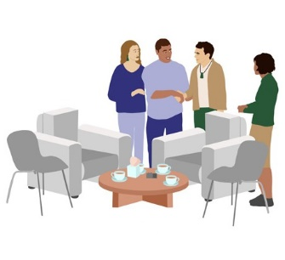

**Step 2**

The survivor and their support person(s) are greeted by the Session Facilitator and Wellbeing person.

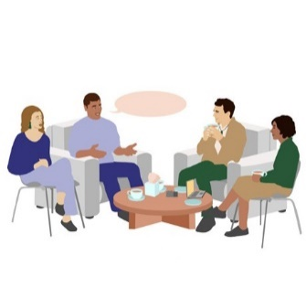

**Step 3**

The survivor and their support person discuss the upcoming private session with the Session Facilitator and Wellbeing person.

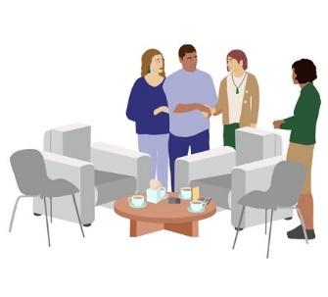

**Step 4**

When the survivor is ready, the Kaitakawaenga will come in and meet the survivor and their support person(s)8

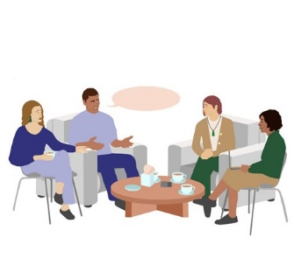

**Step 5**

The survivor will share their experience with the Kaitakawaenga for approximately 90 minutes

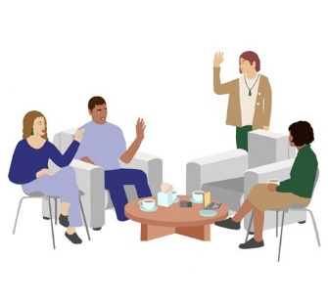

**Step 6**

The Kaitakawaenga will leave the room at the end of the private session

**Step 7**

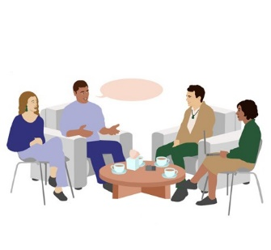

The Session Facilitator and Wellbeing support will check in with the survivor and their support person(s)

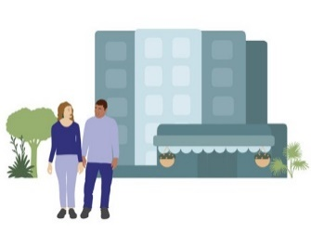

**Step 8**

The survivor and their support person(s) leave the venue

**How you may be feeling now**

He pēhea ō whīra ināianei pea

Sharing your experience may leave you with a feeling that you have been heard, you may feel proud, relieved, or less burdened. You may also be feeling flat, angry, depressed or a mix of many different emotions.

You may already have a plan or strategies you use to cope with strong emotions, and we encourage you to take extra care of yourself.

Here are a few suggestions that you may find helpful:

* *know that these feelings are to be expected*
* *talk to someone you trust, even if you do not feel like it*
* *be kind to yourself*
* *contact us by phone on 0800 456 090*
* *call any of the support services listed at the end of this document*

**What support is available after a private session?**

He aha te tautoko e wātea ana i muri i te mahinga muna?

We will contact you a few days after your private session to check how you are feeling and to ask whether you would like further support.

If you feel like you need additional support after your private session, we can help organise that for you, including if you already have a counsellor or other types of support in place.

If you do not have any ongoing support in place, we will discuss with you what kind of support would be useful for you. We

will arrange for a suitably trained counsellor or support professional to meet with you.

xxxxx

###### Where to get help:

Ki hea tiki āwhina ai:

If you are worried about your or someone else’s mental health, the best place to get help is your GP or local mental health provider.

However, if you or someone else is in danger or endangering others, call police immediately on 111.

Or if you need to talk to someone else:

**LIFELINE:**

0800 543 354

(available 24/7)

**SUICIDE CRISIS HELPLINE:**

0508 828 865 (0508 TAUTOKO)

(available 24/7)

**YOUTHLINE:**

0800 376 633

**NEED TO TALK?**

Free call or text 1737 (available 24/7)

**KIDSLINE:**

0800 543 754

(available 24/7)

**WHATSUP:**

0800 942 8787

(1pm to 11pm)

**DEPRESSION HELPLINE:**

0800 111 757

(available 24/7)

**SAMARITANS:**

0800 726 666



**Information for Support People**

**He mōhiohio ma te hunga tautoko**

### Thank you for agreeing to support a survivor to share their experience with the Service

**Information for Support People**He mōhiohio mā te hunga tautoko

**What does a support person do?**

He aha te mahi a te kaitautoko?

A survivor of abuse may ask a person or people to support

them to share their experience of abuse at a private session.

Survivors will want to be supported in different ways. As a support person your role is to provide the type of support that the survivor would like. The best way to do this is to have a conversation with them about what kind of support they need before, during, and after the session.

**As a support person you may be asked by the survivor to:** Mēnā he kaitautoko koe ka pēnei pea ngā tono a te whakarauora:

* *help them prepare for their session e.g. by reading information or making notes about what they might like to talk about*
* *providing emotional support on the day*
* *talk with them about their feelings in the days and weeks after the session*

**Some things a survivor may ask you to do on the day of the session include:**

Anei ētahi o ngā mea ka tonoa pea e te whakarauora i te rā o te mahinga:

* *travelling with them to and from the venue*
* *helping them to feel comfortable and sitting with them during the session*
* *making sure they have everything they need*
* *asking for a break if they need one*
* *waiting outside the room until the session has finished*

If you are supporting someone who is currently in prison, you will need to be an approved visitor to be able to enter the prison

**What should a support person NOT do?**

He aha ngā mea me KAUA rawa e mahia e te kaitautoko?

During a private session a support person should not speak for the survivor.

This is because the purpose of the private session is for Kaitakawaenga to hear directly from survivors about their experiences.  
  
It is important to remember that it is not the role of a support person to do what you think is best for the survivor, or to make decisions for them.  
  
If you are also a survivor, or a witness of abuse, and would like to share your experience with the Service then you can register by calling 0800 456 090.

**Journalists attending Private Sessions**

Ngā kaikawe kōrero e haere ana ki ngā mahinga muna

Private sessions at the Survivor Experiences Service are an opportunity for survivors to confidentially share their experiences with a Kaitakawaenga. Because of the private nature of these individual sessions and the need for survivors to feel comfortable to speak freely and frankly about their experience, the Service does not permit media to attend.

The Service takes very seriously the need to protect the

privacy and confidentiality of this information and has

clear policies and information management systems in place to do so. If your support person happens to be a journalist by trade, then they are permitted to attend as your support person but not to report on or record the session.

**What is the difference between a support person and an advocate?**

He aha te rerekētanga o te kaitautoko me te kaitaunaki?  
An advocate is a person who has been given permission by a survivor to speak on their behalf e.g. to tell their story for them. Advocates may be family members, friends, or people from organisations. If the person you are supporting wants you to be an advocate

then you and the survivor must speak to us about this before the day of the session.

**What is the difference between a support person and a meeting assistant?**

He aha te rerekētanga o te kaitautoko me te kaiāwhina mō te hui?  
A meeting assistant is a person who can help a survivor to understand information and make decisions about what to do. However, they are not an advocate and cannot speak on the survivor’s behalf. Meeting assistants are very experienced in supporting people with a learning disability or who are neurodiverse. If the person you are supporting is having difficulty understanding information about the Service

or would like extra help to make decisions about whether to take part, please contact us before the day of the session.

**Your wellbeing**

Tō oranga

On the day of the private session there will be a Wellbeing person available for you to

talk to if you need to. There may be parts of the survivor’s experience that you had not

heard before or were distressing to listen to. The Wellbeing person can help you to cope with these emotions.  
  
**Confidentiality**

Matatapu

Private sessions are confidential unless the person you are supporting agrees to the information being made public. Before the private session, the Session Facilitator will ask you to complete a form stating that you understand this.

They will also ask you to confirm that you agree to keep everything said during the private session confidential and that you will not discuss it with anyone else.

This includes other people in your life including; family,

support workers, Corrections officers and employers.

If you do not agree then you will not be allowed to remain in the session.

**Contact**

Whakapā

To find out more about the service, or to register, please call, text or email our Contact Centre.

Freephone (8:30am - 4:30pm NZ time):



**NZ | 0800 456 090**

**AUS | 1800 456 032**

(Call free from Australia)

Text message: 8328

Email:

[contact@survivorexperiences.govt.nz](mailto:contact@survivorexperiences.govt.nz)



Website:

<https://survivorexperiences.govt.nz>

Write to us:



Survivor Experiences Service | Ratonga Wheako Mōrehu

PO Box 805

Wellington 6140