# Tau Vala Tala hagaao ke he haau a Fakatutalaaga Fufū

**

### Kia ora, Fakaalofa lahi atu, Mālō, Talofa, Kia Orana, Bula mo e hello.

#### Fakaaue atu ki a koe he hau ke tufatufa haau a tau logonaaga ke he mahani eke fakakelea fakamamahi.

**Tau Vala Tala ma lautolu ne Hao Mai (Survivors)**

He mōhiohio mā ngā Whakarauora

Iloa e mautolu ko e loto malolo ati maeke ai ke hau ke fakatutala mo mautolu. To taute e mautolu a koe mo e haau a tau vala tala ne kua tufatufa mai e koe ki a mautolu aki e tau manamanatu fakaalofa mo e fakalilifu.

Ko e tau vala tala na ne mui mai ne foaki mai e tau talahauaga hagaao ko e heigoa ke amanaki ki ai he magaaho ka hoko mai a koe ke he Survivor Experiences Service | Ratonga Wheako Mōrehu, ko e heiogoa haau ke taute ke mautali, mo e ko e heigoa ka taute aki e mautolu e tau vala tala ka foaki mai e koe.

**Tau Fakatutalaaga Fufū**

He mahinga muna

Kau uiina atu ki a koe ke lata mo e taha fakatutalaaga fufū ke tufatufa haau a logonaaga ke he mahani eke fakakelea fakamamahi, ke he haau ni a tau kupu vagahau.

To feleveia a koe mo e toko tolu e tagata mai he Survivor Experiences Service, ko lautolu ko e:

* *Taha Kaitakawaenga ka fanogonogo ke he haau a fakamatalaaga, mo e maeke ke fai huhu ke lagomatai ke he ha mautolu a maamaaga.*
* *Ko e taha Tagata ne Fakaholo ke he Fakatutalaaga ne, kaeke ke moua haau a taliaaga tofakamau hifo e tau mena kua fakatutala ki ai, mo e tapaki e taha fakamauaga; mo e*
* *Ko e taha Wellbeing/Oranga Support ka ata ke lagomatai atu ki a koe to hoko, he magaaho tonu mo e ka mole e haau a fakatutalaaga.*

###### Tauteute ke Mau ke lata ma e Fakatutalaaga Fufū

Te Whakarite mō tō Mahinga Muna

Wellbeing **|** Oranga

Foaki atu e mautolu e tau lagomatai nakai totogi mo e tau fakatutalaaga hataki mo e fakamafana he magaaho ka hau a koe ke he Service. To matutaki atu e taha Tagata Lagomatai ke Moua e Malolo Katoatoa (Wellbeing Support person)

ki a koe to hoko e fakatutalaaga ke fakakia kua mafola a koe

**Tauteute mautali ke lata ma e haau a Fakatutalaaga Fufū**

E whakarite ana mō tō mahinga muna

To 60-90 e minute haau ke feleveia mo e Kaitakawaenga.

Ke tauteute mautali ma e haau a fakatutalaaga fufū, liga mitaki ke manamanatu a koe ke he tau mena haau ka manako ke talahau. Ha i ai loga e tau mena ne liga manako a koe ke talahau, mo e kaeke ke manako a koe, ti tohitohi hifo. Kaeke ke manako lagomatai a koe, hea atu ke he Matakau Matutaki mo e Lagomatai.

Ha nai e falu huhu ne liga ke lagomatai a koe:

* *Fefe haau a vaha tama?*
* *Ko e ha ne tuku ai a koe ke he levekiaga?*
* *Ko e heigoa e tau mena ne tutupu ki a ko e he levekiaga?*
* *Ko hai ne taute e mahani eke fakakelea fakamamahi ki a koe?*
* *Talaage nakai e koe ki a taha e tau mena ne fae tutupu ki a koe?*
* *Ko e heigoa e tau mena ne lauia ki a koe ha ko e tau mena ne tutupu ki a ko e he levekiaga?*
* *Fai puhala nakai ne maeke i a koe ke puipui mai he mahani eke fakakelea fakamamahi nei?*

**Aho he Fakatutalaaga Fufū**

Te rā o te mahinga muna

* To fakafeleveia he Tagata Taute Fakaholoaga Fakatutalaaga (Session Facilitator) a koe he aho he haau a fakatutalaaga fufū. To ata e haau a Wellbeing Support ke fakatutala a koe ki ai to fakahoko mo e ka mole e haau a fakatutalaaga fufū. To ata foki e tagata nei he magaaho ka fakahoko e haau a fakatutalaaga kaeke ke manako a koe ke tutala ki ai.
* To hoko atu e Kaitakawaenga, to fakatutala atu e Tagata Taute Fakaholoaga Fakatutalaaga ki a koe hagaao ke he laupepa ne toka ai e fakaataaga mo e ole atu ki a koe ke fakamooli. Ko e laupepa nei ke iloa mooli mo e maali e koe haau a tau tonuhia ha ko e fekau. Ko e taha lagaki he laupepa fakamooli ne lalafi ke he kato nei.
* Ko e magaaho ka mau a koe ke tutala, to finaatu e Kaitakawaenga ke nonofo auloa mo koe mo e taute e tau fakafeleveiaaga haana ki a koe. To kamata e tapakiaga he lakau tapaki, to huhu he Kaitakawaenga ki a koe kua mau nakai a koe mo e fakamanatu atu ki a koe ko e na tapaki mo e fakamau e fakatutalaaga. Kaeke ke fifili ni a koe ko e nakai manako a koe ke tapaki mo e fakamau e fakatutalaaga, maeke agaia ni a koe ke fakahoko haau a fakatutalaaga.
* Maeke i a koe ke fifili ko e lahi fefe e tau mena haau ka talahau. Ke he falu magaaho to huhu atu he Kaitakawaenga e tau huhu ke iloa mooli ko e maama e ia haau a tau mena ne talahau. Manatu tumau, ua talahau kaeke ke nakai manako a koe ke tali po ke talahau ha mena.

**Ka mole haau a fakatutalaaga fufū**

I muri iho i tō mahinga muna

Ka mole e fakatutalaaga, ha i ai e lagomatai ke moua e tau malolo katoatoa kaeke ke manako pihia a koe. Ha ha i ai a ia kaeke ke manako a koe ke fakatutala mo ia po ke ka manako a koe ke he tau vala tala po ke lagomatai hagaao ke iloa e koe e tau puhala ke tavili aki haau a tau mamanatuaga ke he tau aho mo e tau faahi tapu he mole e fekau.

###### Tuga e heigoa e taviliaga nei ka onoono ki ai?

He pēhea te āhua o te tukanga?

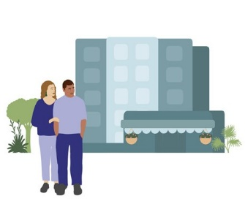

**Lakaaga 1**

Kua hohoko mai a laua ne kua hao mai mo e ha laua a tagata/tau tagata lagomatai ke he tauteaga fekau

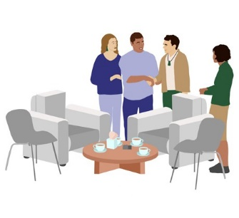

**Lakaaga 2**

To fakafeleveia he Tagata Fakaholo Gahua mo e Tagata Lagomatai ke moua e tau Malolo Katoatoa.

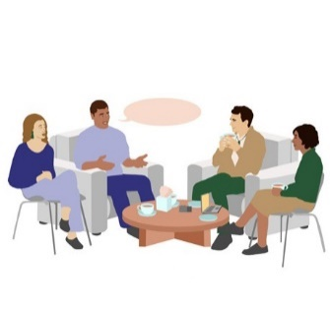

**Lakaaga 3**

To fakatutala he tagata ne hao mai mo e haana a lagomatai e amanakiaga ke he fakatutalaaga fufu mo ia ko e Tagata Taute Fakaholoaga Fakatutalaaga mo e Tagata Lagomatai ke moua e tau Malolo Katoatoa.

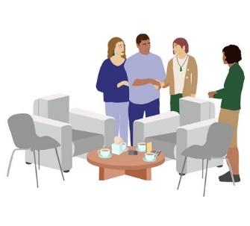

**Lakaaga 4**

Ko e magaaho ka mau a ia ne hao mai, to hau e Kaitakawaenga ke fakafeleveia mo ia mo e haana a tagata/tau tagata lagomatai

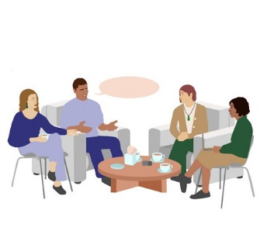

**Lakaaga 5**

To tufatufa e tau logonaaga haana ne hao mai mo e Kaitakawaenga fakataitai ke 90 e minute

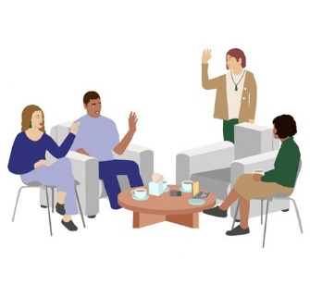

**Lakaaga 6**

To fano kehe e kaitakawaenga mai he poko he magaaho ka fakaoti mai e fakatutalaaga fufū

**Lakaaga 7**

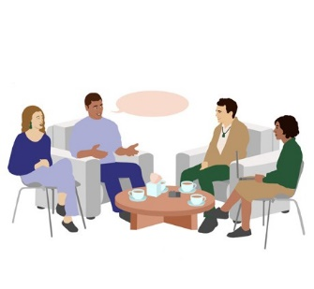

To fakakia he Tagata Fakaholo Gahua mo e Tagata Lagomatai ke moua e tau Malolo Katoatoa a ia ne hao mai mo e haana a tagata/tau tagata lagomatai

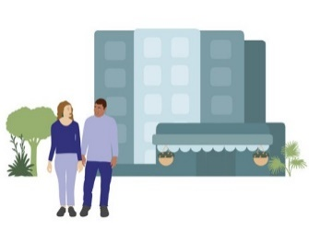

**Lakaaga 8**

Kua o kehe mai a ia ne kua hao mai mo e hana a tagata/tau tagata lagomatai he tauteaga fekau

**Ko e heigoa haau a logonaaga he magaaho nei**

He pēhea ō whīra ināianei pea

Ka tufatufa haau a logonaaga to logona e koe tuga pehe kua fanogonogo e tau tagata ki a koe, liga logona e koe e matalahi, hohoko, po ke ai tuai mamafa e kavega. Liga logona foki e koe e fakaagitau, loto ita, manamanatuaga fakaatukehe po ke fiofio e tau manamanatuaga kehekehe.

Liga kua fita e fai palana a koe po ke tau puhala ne fakaaoga e koe ke maeke ke moua mai e malolo ha ko e tau manamanatuaga malolo, mo e fakamafana atu a mautolu ki a koe ke leveki fakalahi a koe ke he haau a malolo.

Ha nai falu a tau fakataitai ne liga ke lagomatai atu ki a koe:

* *mailoga ko e na pihia tuai ni e tau logonaaga ne amaamanaki ki ai*
* *tutala mo e taha ne falanaki a koe ki ai, pete ni e nakai fia manako a koe ke taute pihia*
* *mahani fakaalofa ni a koe ki a koe*
* *matutaki mai he telefoni 0800 456 090*
* *vilo ke he tau faahi lagomatai ne tohia he matahiku he pepa nei*

**Ko e heigoa e lagomatai ka moua he mole e fakatutalaaga fufū?**

He aha te tautoko e wātea ana i muri i te mahinga muna?

To matutaki atu a mautolu ki a koe ka fai aho ka mole he fakatutalaaga fufū haau ke fakakia ko e fefe e logonaaga haau mo e ke huhu atu ko e manako nakai ke fakaloaloa e lagomatai ki a koe.

Ka logona e koe kua lata ke fai lagomatai atu foki ka mole e fakatutalaaga fufū, maeke i a mautolu ke lagomatai ke taute e taha lagomataiaga ma haau, pete ka fita e fai tagata fakatutala hataki mo e fakamafana po ke fai foki he tau faga lagomatai ne kua fita e fai.

Kaeke ke nakai fai lagomatai moua mau a koe ne kua fita e fakatokatoka, to fakatutala a mautolu mo koe ko e tau lagomatai fefe ne liga lata mo koe. To tauteute e mautolu e taha tagata fakatutala hataki mo e fakamafana po ke taha tagata pulotu ke he tau faahi lagomatai ke fakafeleveia mo koe.

###### Fano ki fe ke moua e lagomatai:

Ki hea tiki āwhina ai:

Kaeke ke tupetupe a koe ha ko e haau po ke he taha foki a tau malolo ke he tau manamanatuaga, mua e mitaki e lagomatai mai he haau a ekekafo po ke faahi gahua malolo ke he tau manamanatuaga ne tata.

Mo ha ia, kaeke ko koe po ke taha foki ne kua matematekelea po ke ha ne fakamatematekelea ke he taha, hea fakamafiti ke tau leoleo he 111.

Po ke ka manako a koe ke tutala mo e taha tagata foki:

**LIFELINE:**

0800 543 354

(ata 24/7)

**SUICIDE CRISIS HELPLINE:**

0508 828 865 (0508 TAUTOKO)

(ata 24/7)

**YOUTHLINE:**

0800 376 633

**NEED TO TALK?**

Tau hea nakai totogi po ke tohi hila 1737 (ata 24/7)

**KIDSLINE:**

0800 543 754

(ata 24/7)

**WHATSUP:**

0800 942 8787

(1 afiafi ke he 11 afiafi)

**DEPRESSION HELPLINE:**

0800 111 757

(ata 24/7)

**SAMARITANS:**

0800 726 666



**Tau vala tala ma e tau Tagata Lagomatai**

### Fakaaue ha kua talia e koe ke lagomatai ke he taha ne kua hao mai ke tufatufa haana a tau logonaaga mo e Service

**Tau vala tala ma e tau Tagata Lagomatai**

He mōhiohio mā te hunga tautoko

**Ko e heigoa he tagata lagomatai ka taute?**

He aha te mahi a te kaitautoko?

Ka huhu he tagata ne hao mai he tau mahani eke fakakelea fakamamahi e taha tagata po ke tau tagata ke lagomatai a ia ke tufatufa haana a tau logonaaga ke he mahani eke fakakelea fakamamahi he taha fakatutalaaga fufū.

To manako a lautolu ne hao mai ke lagomatai ke he tau puhala kehekehe. Ha ko koe ko e tagata lagomatai ko koe ka foaki e tau faga lagomatai ke manako a ia ne hao mai ki ai. Ko e puhala ne mua ke fakatutala mo ia hagaao ke he tau manako lagomatai to hoko, he magaaho ka fakahoko ai, mo e ka mole e fakatutalaaga.

**Ha ko e tagata lagomatai a koe to liga ole he tagata ne hao mai ke:** Mēnā he kaitautoko koe ka pēnei pea ngā tono a te whakarauora:

* *lagomatai ke tauteute mautali ke lata ma e haana a fakatutalaaga tuga e totou e tau vala tala po ke fakamau hifo falu matakupu hagaao ke he tau mena ne liga manako a ia ke fakatutala ki ai*
* *foaki e tau lagomatai fakamafana he aho*
* *tutala mo ia hagaao ke he ha lautolu a tau manamanatuaga he tau aho mo e tau faahi tapu he mole e fakatutalaaga*

**Ko e falu mena ne liga ke ole atu e tagata ne kua hao mai ke taute he aho ka fakatutala ai:**

Anei ētahi o ngā mea ka tonoa pea e te whakarauora i te rā o te mahinga:

* *fenoga atu mo ia mo e fano kehe mai he tauteaga he fekau fakatutala*
* *lagomatai a lautolu ke logona e hagahaga mitaki mo e nonofo mo ia he magaaho ka fakahoko e fekau fakatutala*
* *onoono kua katoatoa e tau mena ne manako a ia ki ai*
* *huhu age ko e manako nakai ke fai okioki fakaku kaeke kua manako*
* *fakatali i fafo he poko to oti e fekau fakatutala*

Kaeke ke lagomatai a koe he taha tagata ne ha ha ki loto he fale puipui, kua lata i a koe ke moua e fakaataaga ke hu atu ke fale puipui

**Ko e heigoa he tagata lagomatai ka NAKAI taute?**

He aha ngā mea me KAUA rawa e mahia e te kaitautoko?

Kua nakai lata e tagata lagomatai ke gutu vagahau ma e tagata ne hao mai.

Pihia ha ko e kakano he tau fakatutalaaga fufū ke fanogonogo fakahako mai ni i a ia ne hao mai e tala hagaao ke he ha lautolu a tau logonaaga.

Mahuiga lahi ke manatu ko e nakai ko e gahua he tagata lagomatai ke taute e mena ne manatu a ia kua hako ke lata ma haana ne kua hao mai, po ke taute e tau fifiliaga ma haana.

Kaeke ko koe ne hao mai, po ke onomata e koe e mahani eke fakakelea fakamamahi, mo e manako a koe ke tufatufa e haau a tau logonaaga mo e Service maeke i a koe ke fakamau haau a higoa ka tau hea atu ke he numela 0800 456 090.

**Haau a malolo katoatoa**

Tō oranga

Ko e aho he fakatutalaaga fufū to ha ha i ai e taha mai he tau tagata Wellbeing ne ata ma haau ke

tutala ki ai kaeke ke manako a koe. To liga ke loga e tau vala he tagata ne kua hao mai ne kua nakai

logona e ko e fakamua po ke logona e tupetupe he loto he fanogonogo ki ai. To maeke he tagata Wellbeing ke lagomatai a koe ke fahia ke totoko ke he tau manamanatuaga fakaatukehe nei.

**Ufitia ke he tau mena galo**

Matapatu

Ufitia e tau fakatulaaga fufū a to talia he tagata ne lagomatai a koe ki ai ke fakatokanoa e tau vala tala ke iloa he moto tagata papiliki. To fakahoko e fakatutalaaga fufū, to ole atu he Session Facilitator ke fakapuke e taha laupepa ke fakamooli kua maama e koe e tau mena nei.

To ole atu foki e lautolu ki a koe ke fakamooli kua talia e koe ke ufitia oti e tau mena ne vagahau he fakatutalaaga fufū mo e to nakai fakatutala e koe e tau mena nei mo taha.

Putoia e mena nei ke he tau tagata oti he haau a moui; haau a magafaoa,

tau tagata lagomatai, tau ofisa fale puipui (Corrections officers) mo e tau pule fakagahua tagata.

Kaeke ke nakai talia e koe to nakai maeke a koe ke nofo he fakatutalaaga.

**Tau tagata tohi tala fakapuloa ne fakalataha atu ke he tau Fakatutalaaga Fufū**

Ngā kaikawe kōrero e haere ana ki ngā mahinga muna

Ko e tau fakatutalaaga fufū ne fakahoko he Survivor Experiences Service ko e taha magaaho ne fakaata ki a lautolu ne kua hao mai ke tufatufa fufū ha lautolu a tau logonaaga mo e taha Kaitakawaenga. Ha ko e puhala fakagalogalo he tau fakatutalaaga nei mo e manako ha lautolu ke logona e mafanatia ke tutala nakai tautaofi mo e folafola mo e nakai maimaina hagaao ke he ha lautolu a tau logonaaga, to nakai fakaata he Service e tau tagata tohi tala mo e fakapuloa tala ke fakalataha atu.

Ne fakamamafa lahi e Service ke puipuiaga mo e ufitia e tau vala tala mo e ha i ai e fakatokaaga he tau poakiaga ne mahino mitaki mo e tau levekiaga ke he tau vala tala. Kaeke ko e tagata tohi tala ke fakapuloa foki e haau a tagata lagomatai, maeke i a ia ke fakalataha atu ha ko e tagata lagomatai haau ka e nakai ke hokotaki po ke tapaki e tau taofiaga he fakatutalaaga.

**Ko e heigoa e fekehekeheaki mai he tagata lagomatai (support person) mo e tagata mo e tagata gutu vagahau (advocate)?**

He aha te rerekētanga o te kaitautoko me te kaitaunaki?

Ko e tau tagata gutu vagahau ne kua moua e fakaataaga mai i a ia ne kua hao mai ke eke mo gutu vagahau ke talahau e tala haana. Maeke ke fakaaoga he tau tagata mai he magafaoa, tau kapitiga, po ke tau tagata mai he falu matakau ke eke mo tau tagata gutu vagahau. Kaeke ke manako e tagata haau ne lagomatai ke eke a koe mo gutu vagahau ti kua lata a mua ke talahau ki a mautolu hagaao ke he mena nei to hoko e fakatutalaaga.

**Ko e heigoa e fekehekeheaki mai he tagata lagomatai (support person) mo e tagata mo ia ne lagomatai fono (meeting assistant)?**

He aha te rerekētanga o te kaitautoko me te kaiāwhina mō te hui?

Ko e lagomatai fono ko e tagata ne maeke ke lagomatai a ia ne hao mai ke maama e tau vala tala mo e taute e tau fifiliaga ko e heigoa ke taute. Mo ha ia, nakai ko e tau gutu vagahau a lautolu mo e nakai maeke ke eke mo gutu vagahau ma lautolu ne kua hao mai. Ko e tau lagomatai fono ne mahani lahi ke lagomatai e tau tagata ne nakai malolo ke he tau fakaakoaga po ke ko lautolu ne kehekehe e tau taviliaga he manamanatu ke he tau mena tutupu. Kaeke ke fai ukauka a ia ne lagomatai a koe ki ai ha kua nakai maeke ke maama e tau vala tala hagaao ke he Service po kua manako ke moua foki e taha lagomatai ke fifili ko e fakahoko nakai e fakatutalaaga, fakamolemole ti matutaki mai ki a mautolu to hoko e aho ka taute e fekau nei.

**Matutaki**

Whakapā

Ke kumikumi ke iloa atu e tau vala tala ke he Service, po ke ke fakamau hifo e higoa, fakamolemole ti tau hea mai, tohi hila po ke meli hila mai ke he ha mautolu a Contact Centre.

Telefoni nakai totogi (8:30 pogipogi – 4:30 afiafi taimi NZ):



**NZ | 0800 456 090**

**AUS | 1800 456 032**

(Tau hea nakai totogi mai i Osetalia)

Tohi hila (text): 8328

Meli hila:

[contact@survivorexperiences.govt.nz](mailto:contact@survivorexperiences.govt.nz)



Poko Kupega Hila:

<https://survivorexperiences.govt.nz>

Tohi mai ki a mautolu:



Survivor Experiences Service | Ratonga Wheako Mōrehu

PO Box 805

Wellington 6140