

Survivor Experiences Service -   
Complaints Process

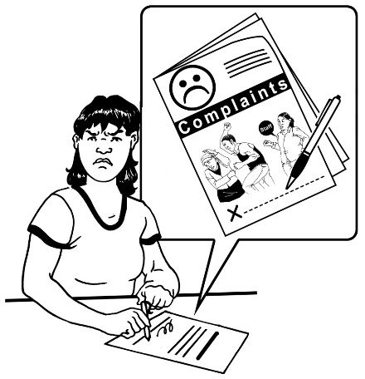

Published: June 2024

# Before you start



This document talks about abuse.

This information may upset some people when they are reading it.



This information is not meant to scare anyone.

If you are upset after reading this document you can talk to your:

whānau / family

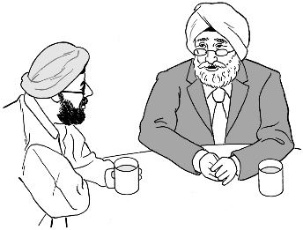friends.

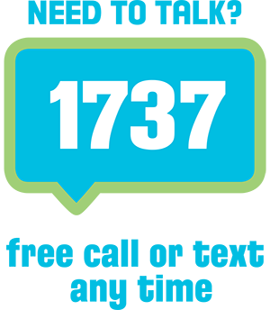You can also contact Need to Talk by:

calling 1737

texting 1737



It does not cost any money to call / text 1737.



If you do not feel safe call the police on **111.**

# What you will find in here



**Page number:**

What this document is about 5

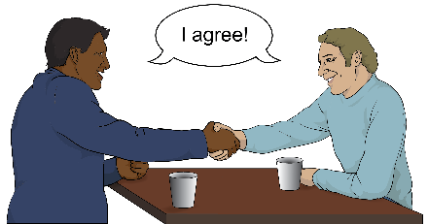

Our commitment 9

Our complaint processes 11

Early resolution 12



The 3 stages of our   
formal complaint process 13

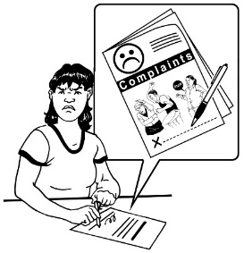

How to send us your complaint 15

**Page number:**



Information you need to give us 18

When we will reply to   
your complaint 20

When to send us your complaint 21



How to contact us 22

# What this document is about



This Easy Read document is from the **Survivor Experiences Service.**



In this document when we say **the service** we mean the **Survivor Experiences Service**.

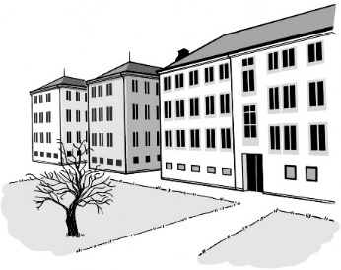The **service** is for:

* people who have experienced **abuse** while **in care**
* 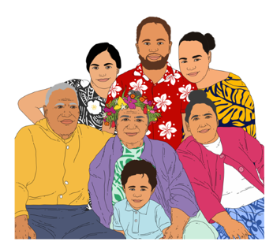people to talk about what happened to them
* people and their   
  whānau / families to get the support they need.

**Abuse** can be:

**physical** – kicking or hitting you

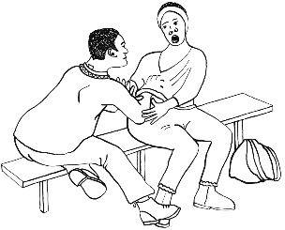**sexual** – doing sexual things to you that you do not want like:

* 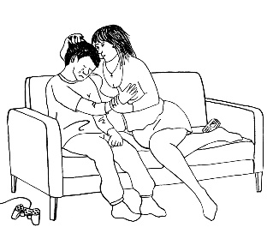touching your body or private parts
* kissing you
* making you have sex – this is called rape

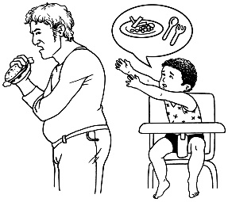**emotional** – yelling or saying things to you that are not nice

**neglect** – not giving you the things or care you need.

In this document being **in care** means that the Government or a **faith-based institution** was in charge of your care.



**Faith-based institutions** are run by religious groups like churches.



People who have been through abuse in care are sometimes called **survivors**.



More information about the service can be found on their website here:

[**www.survivorexperiences.govt.nz**](http://www.survivorexperiences.govt.nz)



This information on the website is **not** in Easy Read.

This Easy Read document is about how to make a **complaint** about the service.

A **complaint** is telling someone:

there is a problem

something is wrong.

# Our commitment



Our **commitment** is our promise to you.

We will:

make it easy for anyone to make a complaint

deal with all complaints:

* 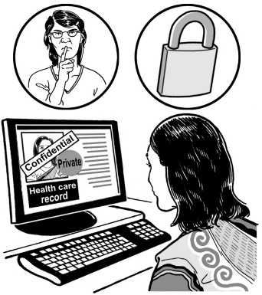fairly
* confidentially – we will not tell anyone what you have said unless you tell us it is okay
* with care

let you know if your complaint has been **resolved**.

** Resolve** means to fix / make something better.

We will also:

let you know if your complaint can not be fixed

apologise if we have done something wrong

do our best to make things better

make sure that what your complaint is about does not happen again.

# Our complaint processes



There are **3 stages** to our complaint process.

**Stages** are the things that are done when looking at your complaint.



On **pages 13 and 14** you can find more information about each of these stages.



Before going through our formal complaint process we will try to sort out your complaint in our **early resolution** process.

# Early resolution

If you have a complaint you should:

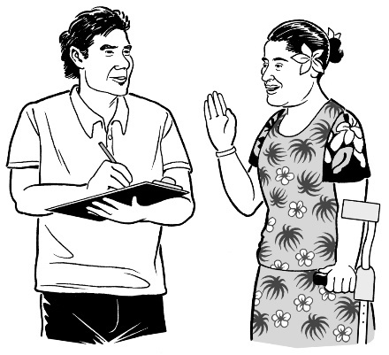tell the service staff member you have been communicating with what your complaint is about

ask the service staff member you have been communicating with to resolve your complaint.

If you are not happy with how your complaint has been resolved you can send us a formal complaint.

# The 3 stages of our formal complaint process



At stage 1 your complaint will be looked at by a **senior manager** from our service.

A **senior manager** is someone who looks after a team of staff.



If you are unhappy with our response to your complaint at stage 1 you can ask for your complaint to be sent to stage 2.

At stage 2your complaint is looked at by the **Executive Director** of the service.

An **Executive Director** is the head of a company or organisation.



If you are still unhappy with the response to your complaint you can ask for your complaint to be sent to stage 3.

At stage 3 your complaint is looked at by the **Chair** of the service.

The job of the **Chair** is to make sure the service works well.



This is the last stage of our formal complaint process.

# How to send us your complaint



You can send us your formal complaint by:

****posting a letter to:  
  
**Complaints  
Survivor Experiences Service  
PO Box 805  
Wellington 6140**

calling us on:  
  
**0800 456 090**

texting us on: **8328**

emailing us at:

[**complaints@survivorexperiences.govt.nz**](mailto:complaints@survivorexperiences.govt.nz)

If you are sending us an email for your complaint to be sent to **stage 2** it is important to remember to write:

**Complaint, attention Executive Director** in your email subject line

why you feel like your complaint has not been resolved

what your complaint is about.

If you are sending us an email for your complaint to be sent to **stage 3** it is important to remember to write:

**Complaint, attention of the Chair** in your email subject line

why you feel like your complaint has not been resolved

what your complaint is about.

If your complaint is about the Chair please send your email to the:

Executive Director with the email subject line **Complaint, attention Executive Director**

same email address:

[**complaints@survivorexperiences.govt.nz**](mailto:complaints@survivorexperiences.govt.nz)

# Information you need to give us



To make sure your complaint is looked over properly please give us the following information:

the name of the staff member who assisted you in early resolution

your personal details such as your:

* 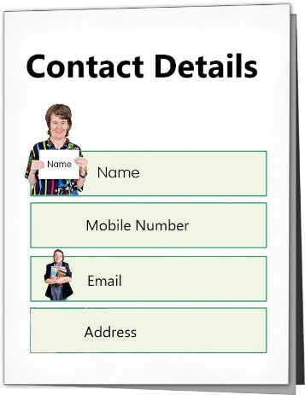full name
* postal address
* email address
* phone number

how you would like us to contact you.

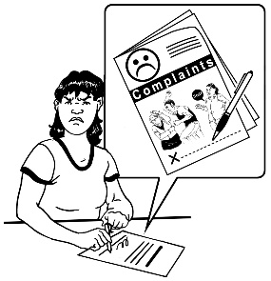Other information that you need to give us is:

details about your complaint such as:

* what happened
* the date it happened
* any documents that show what happened like emails

what you want to happen.

# When we will reply to your complaint



We will send you a reply to say that we have your complaint within   
3 working days.



**Working days** means Monday to Friday.

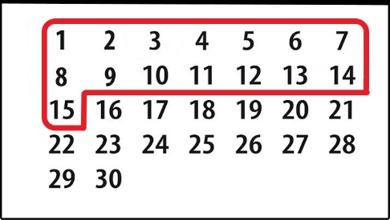

We will usually reply to your complaint within 1 to 15 working days.



If we can not respond to you within   
1 to 15 working dayswe will contact you to let you know why.

# When to send us your complaint

You can send us a complaint at any time.

It is best if you send us your complaint as soon as possible after you have a problem / issue with the service.

# How to contact us



You can phone us on:

**0800 456 090**



If you are in Australia you can phone us on:

**1800 456 032**



It does not cost money to call these numbers.

You can phone us from:

8:30 in the morning



to

4:30 in the afternoon.



These times are for the New Zealand time zone.

****You can use the **New Zealand Relay service** to call us.

If you find it hard to use the phone the **New Zealand Relay** service is for people who are:

* Deaf / hard of hearing
* deafblind
* speech impaired / find it hard to talk.

You can find out more about the New Zealand Relay service at:

**www.nzrelay.co.nz**

You can text us on:

**8328**

You can send an email to:

[**contact@survivorexperiences.govt.nz**](mailto:contact@survivorexperiences.govt.nz)

****You can write to us at:

**Survivor Experiences Service**

**PO Box 805**

**Wellington 6140**

This information has been written by the Survivor Experiences Service.

It has been translated into Easy Read by the Make it Easy Kia Māmā Mai service of People First New Zealand Ngā Tāngata Tuatahi.



The ideas in this document are not the ideas of People First New Zealand Ngā Tāngata Tuatahi.

Make it Easy uses images from:

* Photo SymbolsChangepeople.org

Photosymbols.com

* SGC Image Works
* Huriana Kopeke-Te Aho
* T. Wood.

  
All images used in this Easy Read document are subject to copyright rules and cannot be used without permission.